Project Proposal

StudySync Web Extension

Sunidhi Abhange

Gage Fleming

Hashem Ramadan

Mason Waldapfel

University of London

CM2020 Agile Software Projects

Team 68 (Tutor Group 6)

Table of Contents

1 Introduction 4

2 Vision and Scope 6

2.1 Project Requirements 6

2.1.1 Project Opportunity 6

2.1.2 Comparative Evaluation 7

2.1.3 Project Problems and Objectives 23

2.1.4 Success Metrics 25

2.1.5 Vision Statement 25

2.1.6 Project Risks 25

2.1.7 Project Assumptions and Dependencies 26

2.2 Scope and Limitations 26

2.2.1 Major Features 26

2.2.2 Scope of the Development Process. 28

2.2.3 Limitations and Exclusions 30

2.3 Project Context 31

2.3.1 Stakeholder Profiles 31

2.3.2 Project Priorities 32

2.3.3 Deployment Considerations 32

3 User Requirements 33

4 Software Requirements Specification 39

4.1 Introduction 39

4.1.1 Purpose 39

4.2 Overall Description 39

4.2.1 Product Perspective 39

4.2.2 Operating Environment 39

4.2.3 Design and Implementation Constraints 40

4.2.4 Assumptions and Dependencies 40

4.3 System Features 40

4.3.1 Interact with the Extension via the Dropdown Menu 40

4.3.2 Navigate the HTML Pages via the Navbar 41

4.3.3 Edit the Whitelist Form 41

4.3.4 Whitelist all Attempted URL Queries 42

4.3.5 Track Coursera Study Time 42

4.3.6 View Time-Tracker Stats on Data Dashboard 43

4.3.7 Adjust Time-Tracker Settings 43

4.4 Data Requirements 44

4.4.1 Logical Data Model 44

4.4.2 Data Dictionary 44

4.4.3 Reports 45

4.4.4 Data Acquisition, Integrity, Retention, and Disposal 45

4.5 External Interface Requirements 46

4.5.1 User Interfaces 46

4.5.2 Software Interfaces 46

4.6 Quality Attributes 46

4.6.1 Usability 46

4.6.2 Performance 46

4.6.3 Security 46

4.6.4 Safety 47

5 Prototypes 47

5.1 Low-Fidelity Prototypes 47

5.1.1 Prototype One 47

5.1.2 Prototype Two 50

5.1.3 Prototype Three 51

5.2 Low-Fidelity Prototype Questionnaire 52

5.3 High-Fidelity Prototype 53

5.4 High-Fidelity Prototype Questionnaire 56

6 Conclusion 56

7 Appendix 56

7.1 Questionnaires 56

7.1.1 Coursera Questionnaire 56

7.1.2 Low-Fidelity Prototype Questionnaire 64

7.1.3 User Requirements Questionnaire 68

7.1.4 High-Fidelity Prototype Questionnaire 73

7.2 Storyboards 73

7.2.1 US-2 Storyboard 73

7.2.2 US-6 Storyboard 74

# 

# 1 Introduction

Coursera is a global platform specializing in online learning and career development. The platform allows millions of learners to grow, learn, and develop industry-standard skills through partnerships with universities, businesses, and governments. It has affected each of the author's lives via the Bachelor of Computer Science offered in collaboration with the University of London and allows a further 113 million learners the opportunity to cement lifelong learning as an integral part of their lives.

As avid users of the Coursera platform, we see an opportunity to enhance the platform via a browser extension. The overall goal of the extension is to aid in implementing and improving BSc student's successful study skills. The extension will allow students to limit distractions by implementing a whitelist website blocker. It will also enable users to optimize their study patterns with analytics driven by a time tracker.

The tool’s value within the given market space, design and planned implementation have been thoroughly refined through our team's quality research, planning and iteration to ensure the tool meets the needs of our market audience.

# 2 Vision and Scope

## 2.1 Project Requirements

### 2.1.1 Project Opportunity

Coursera serves over 113 million learners worldwide, offering a large demographic to tap into. While building a web extension that caters to all of these students is unreasonable, we have direct access to around 10,000 unique learners currently enrolled in the same program as the StudySync team. These users display constant frustration with online distractions and the need for study habit tools. Our preliminary questionnaire confirms the desire for a tool of this nature. Users are frequently distracted by unrelated websites, need help to focus on their Coursera studies and try to implement a wide array of technologies to mitigate this problem. They also see value in a time tracker, which helps display their study habits' effectiveness by semester. The complete questionnaire can be viewed in the appendix.

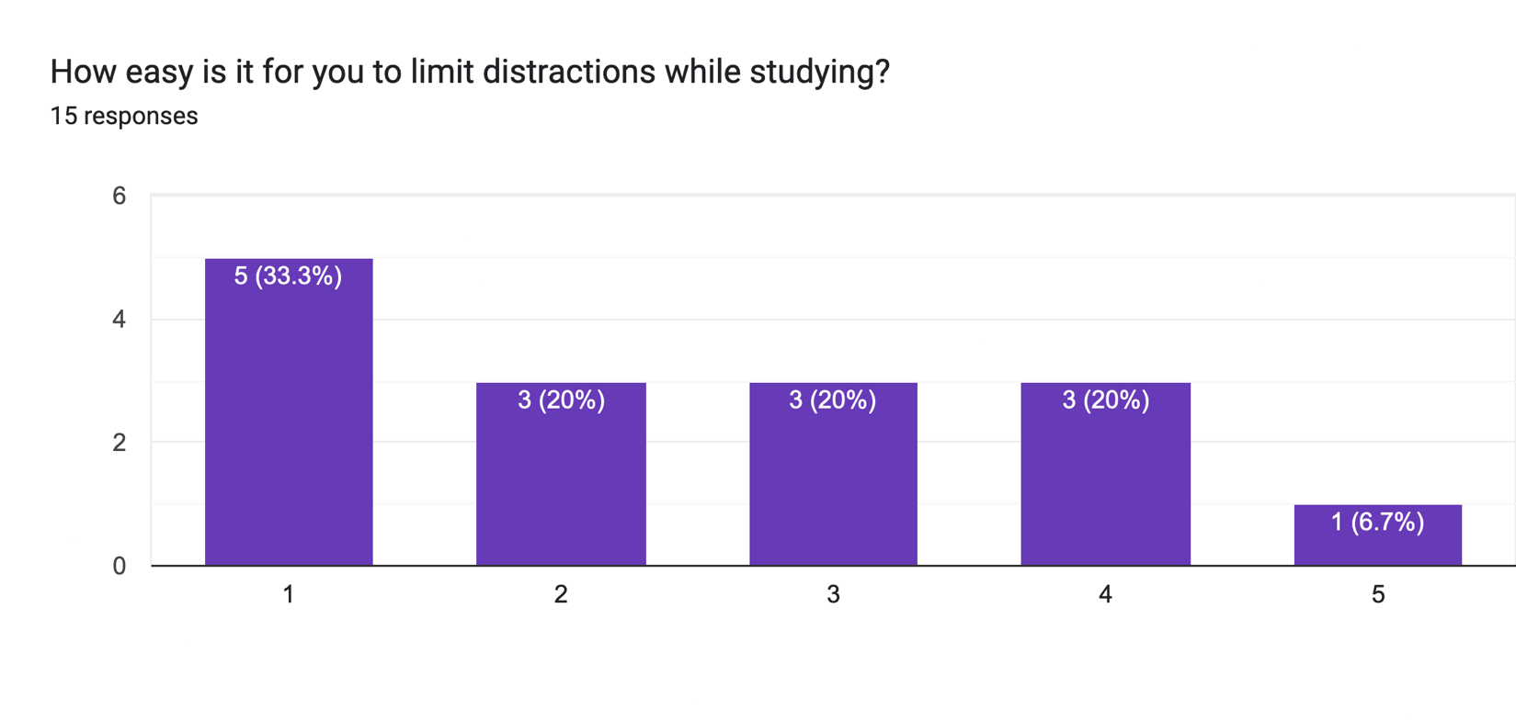

Figure 1: Questionnaire responses regarding limiting distractions while studying on Coursera. Scale: 1 - very hard to limit, 5 - very easy to limit.

A comparative analysis follows to see the current market solutions and how StudySync will fit within this ecosystem. In brief, the current website blockers perform well and provide many functions to increase the student's productivity. However, they all require high upfront setup costs, aren’t built directly for Coursera, and can ask for payment to be of actual use. The time trackers also suffer from the same issues the website blockers do. The lack of Coursera integration is apparent here, as users cannot accurately understand their study time per course or task. The high barrier to entry for these solutions also limits the number of students who will put in the effort to solve this problem. With this in mind, combined with the results from our initial user research, we see this as an excellent opportunity to produce a fit-for-purpose web extension with a low barrier to entry.

The web extension would limit the barrier to entry by providing base settings that integrate well with the average student’s desired settings. It would also be a free web extension. Focusing on Coursera integration would provide a relevant, accurate picture of study habits on the platform. The web blocker would be a whitelist as opposed to a blacklist which would limit the decisions needed by the user. These options would combine to provide the best productivity tool for students to pair with their Coursera studies. The direct access to the degree students is an excellent testing ground to get an MVP product tested, produced and published.

### 2.1.2 Comparative Evaluation

#### 2.1.2.1 Limit

Limit is a web extension which limits the time you can spend on distracting websites, offering a solution to PP-2. It is a lightweight tool that allows users to input problematic websites and set daily time limits. Limit is built on a blacklist in which the onus is on the user to find and declare websites which are problematic to their productivity time.

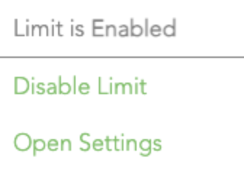

Figure 2: Limit dropdown menu.

The extension also helps pinpoint desirable traits for an app of this nature. The UI is simple, with clear, interactive elements and visual distinction to help guide the user through its functionality. The tool does not contain bloatware or unnecessary functionality to further the usability of the extension. It also indicates Limit takes privacy seriously, and the data used by the application is stored locally on the user’s machine without being sent to a database or the cloud. The lack of a paywall also helps user uptake and lowers the barrier to entry.

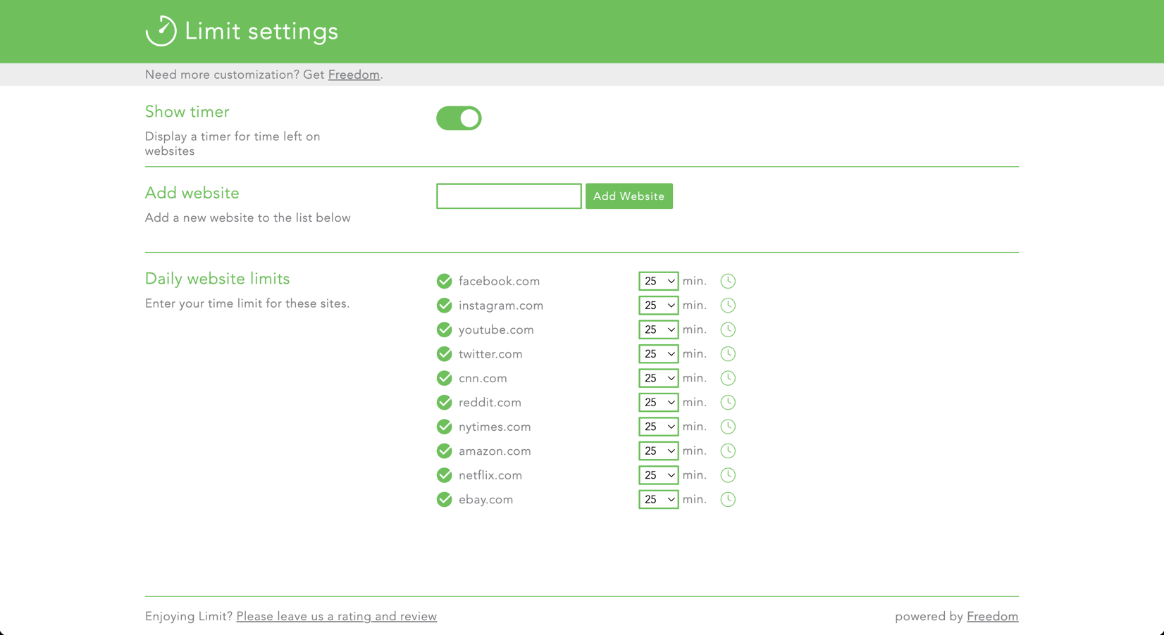

Figure 3: Limit settings page.

Limit offers a solution to our project problem PP-2 by allowing users to limit time spent on websites they see as distracting. However, when framed within our desired user class, we don’t see it as a good fit.

To start, the web extension is a blacklist which comes with a high overhead cost to set up correctly. Users must document all websites they see as problematic and write them into the extension. Meanwhile, StudySync would be a whitelist that removes this overhead time by stopping everything by default. The user would then have quick access to add URLs to the whitelist.

Furthermore, the extension still allows access to these problematic sites for a limited time. Users can get engulfed in a task on a given website when permitted. For example, a user is writing a comment to a Facebook post, and Limit jumps in and says the site is now blocked as they have spent too much time on Facebook. Users can get frustrated and turn off the extension to complete their comments. The user then forgets to enable the extension, and their study sessions are again at the mercy of distracting websites. StudySync would solve this by preventing access from the start during study sessions. This would stop users from investing in these distracting sites during their study sessions.

#### 2.1.2.2 Web Blocker

Web Blocker is a web extension which serves as a simple blacklist for distracting websites, offering a solution to PP-2. The extension redirects users to a specified URL when they try to navigate to a blacklisted URL. Like Limit, it puts the onus on the user to find and document problematic websites for the extension to block.

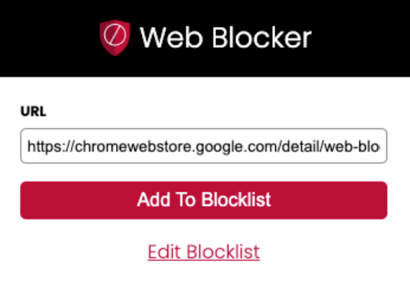

Figure 4: Web Blocker dropdown menu.

Web Blocker provides all of its functionality with very little user interaction. The user does not need to go through complicated workflows to block pages. The extension does not contain bloatware and contains fit-for-purpose functionality. Much like Limit, the extension would allow a user to get quickly acquainted with its functionality—a vital aspect of these extensions. The redirect option is also a unique solution for blocking the page, but it could lead to confusion as no alert is provided when the user is redirected. Web Blocker also does not hide behind a paywall, which we see as a necessity for any web extension of this kind.

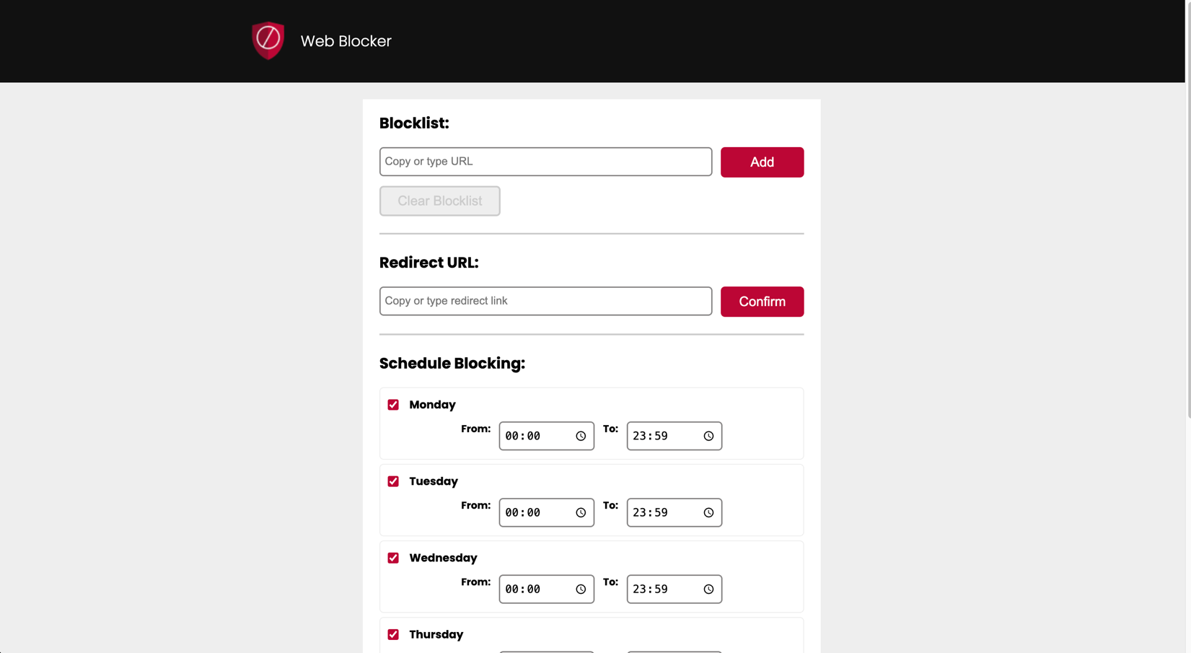

Figure 5: Web Blocker settings page.

Web Blocker performs well as a blacklist web extension. However, much like Limit, its broad nature and high setup costs leave much to be desired. The user will again have to find and list all problematic pages in the extension. We see this as a high entry barrier in these kinds of extensions. The extension also does not offer a simple on/off toggle to disable the blocker. Users can switch productivity mindsets, and with this extension, it would need to be entirely turned off to allow for that switch. We don’t see this as a good solution, as the extension could be forgotten once disabled. StudySync could ask users if they want it enabled after navigating to coursera.org.

#### 2.1.2.3 WebWork

WebWork is a full-fledged productivity tool which allows companies to track and monitor employee productivity and automate payroll tasks. The web extension provided by the company fits within PP-3. While the features offered by the company are geared more toward employee and company productivity, some features here can be attractive to our target market.

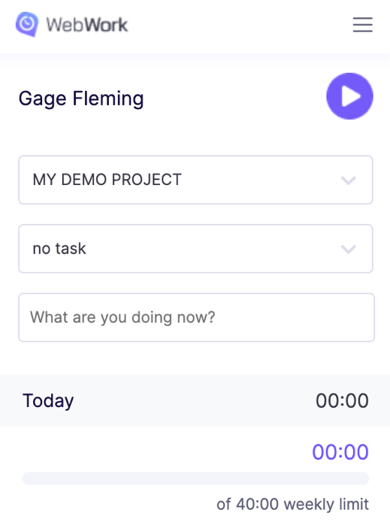

Figure 6: Webwork dropdown menu.

The application allows users or managers to set a weekly limit to the work that can be completed by the individual in question. The individual can then choose what project, task and information they are working on by inputting it into the extension. WebWork then processes this information, allowing users to see their productivity or use it for reports or payroll.

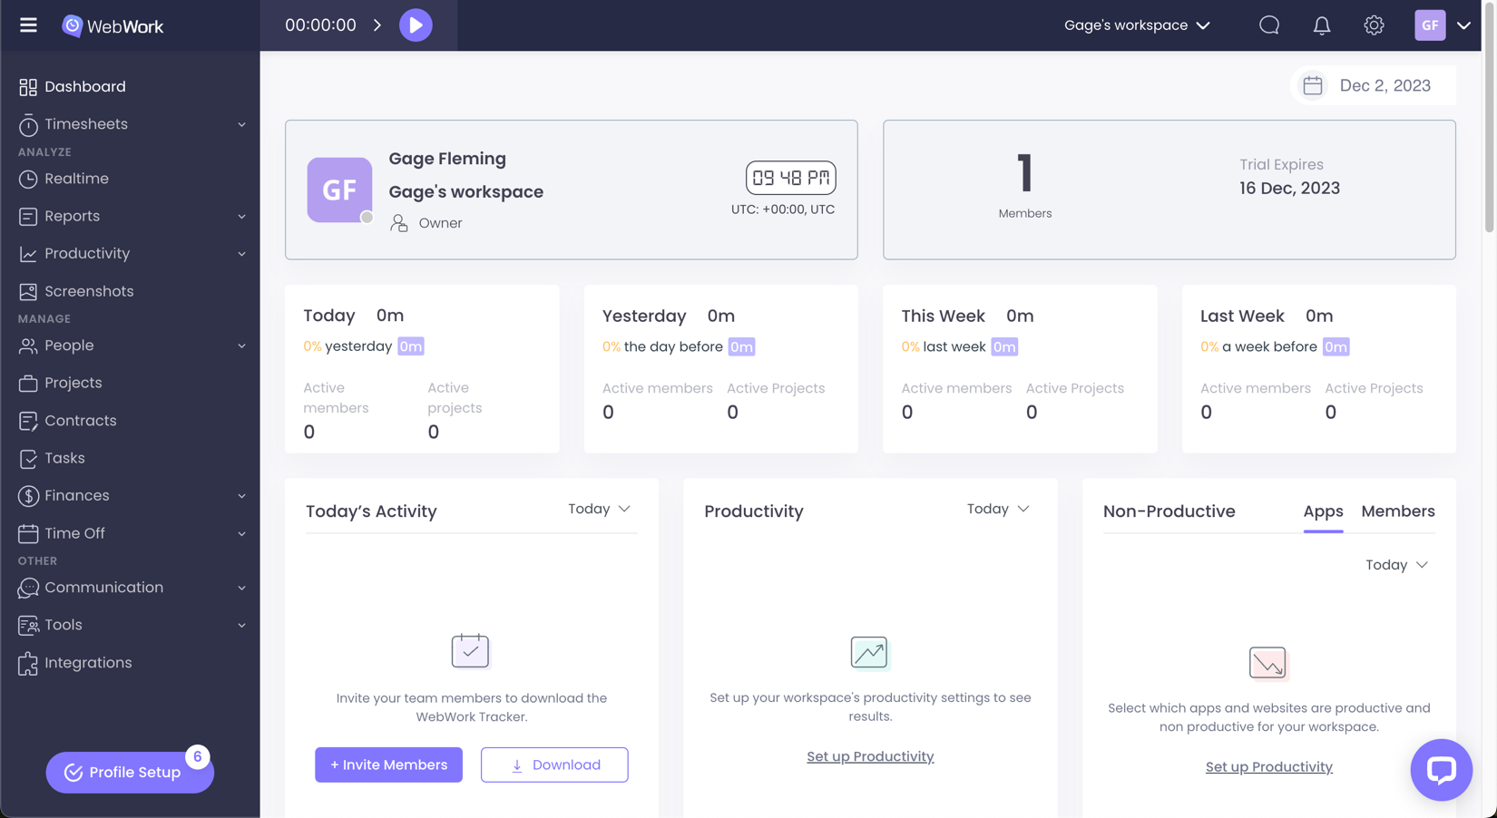

Figure 7: Webwork dashboard.

The simple design of the dropdown menu and task breakdown are great tools which would translate well into StudySync. Users should be able to quickly enter the information they need and be guided toward the correct input area. The many reports and data visuals also benefit the company's productivity market.

In contrast, when framed within our current market, we see WebWork as an overfit solution for our users. It’s locked behind a paywall, requires a user account, which is very difficult to close, and has a high barrier to entry with all the different options, reports and visuals. Our target market does not want a lot of setup costs, and the complexity of this tool does not lend itself well to that mindset. The tool also asks for a high degree of invasion regarding a user's privacy. Many students are privacy-focused, which can be an off-putting ask. While this tool seems an excellent fit for companies within our problem space, it doesn’t correctly solve PP-3 for our market demographic.

#### 2.1.2.4 Web Activity Time Tracker

Web Activity Time Tracker is a web extension that tracks users' time spent on websites and stores data for visualizations and output. The extension also allows users to limit time spent on specific websites through a blacklist. The extension provides a solution to both PP-2 and PP-3.

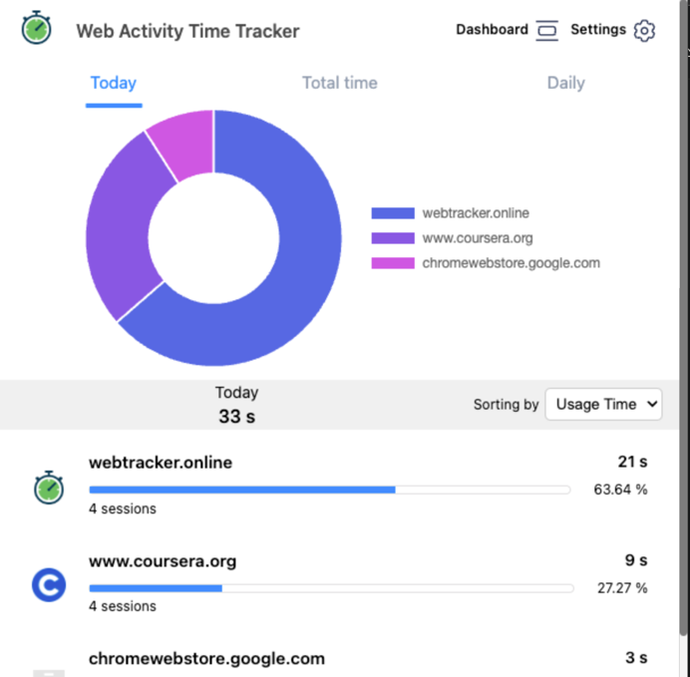

Figure 8: Web Activity Time Tracker dropdown menu.

The extension is of quality build, simple in design, functionally sound, and provides instant feedback to users. The visualizations are also well thought out and allow the user to make quick adjustments if they notice a little too much time is spent on a particular website through the pie chart. The extra options enable power users to flesh out the tool further and narrow in on a quality time tracker. This extension has a lot of positive points, and how it displays itself lowers the barrier for entry and provides clear I/O feedback, which is something StudySync should strive to achieve.

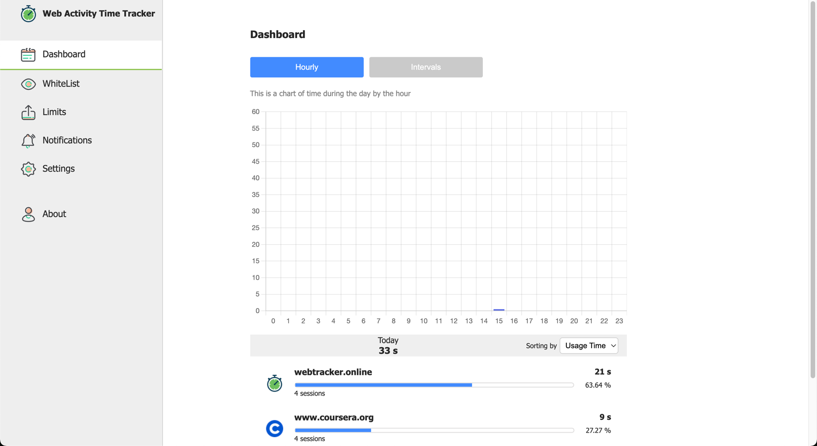

Figure 9: Web Activity Time Tracker dashboard.

While this tool fits the best within our problem area so far, it still has some things that could be improved for our user demographic. To start, the extension tracks pages based on the overall homepage URL, not the specific page the user is on. Therefore, when studying on Coursera, the user is considered to be on Coursera.org at all points. This means the user could only see their total time spent on the site instead of breaking it down by course and task, which fails to meet the user's expectations for a tool that enables Coursera time tracking. The tool also fails in blocking websites as it is like some extensions before it: a limiter instead of a whitelist, which we see as the inferior solution to limiting distracting websites.  
  
This extension is an excellent tool for general time tracking, but our market users want something more catered to Coursera.

#### 2.1.2.5 Blocksite

Blocksite is a web extension which enables website blocking via white- or blacklists. It also provided some peripheral information, such as light site tracking. All this provides a solution to PP-2 and somewhat to PP-3. The addition of a whitelist is a great tool which StudySync thinks is the best solution for website blocking. Unfortunately, getting actual functionality out of the extension involves a paywall.

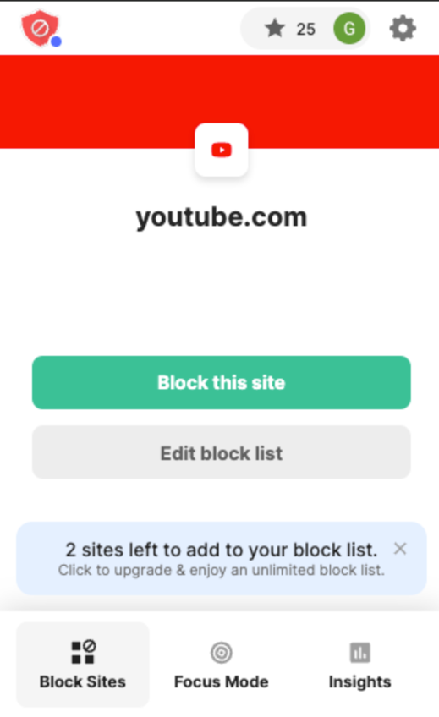

Figure 10: Blocklist dropdown menu.

The extension is straightforward and functionally sound. The ease with which URLs are added to the blocklist and the feedback the extension provides users allows for a quality tool. The responsive feedback to user actions is also a plus for the extension. Unfortunately, we cannot get an accurate comparison for this extension due to the paywall, and that is the extension's biggest downfall. Free users can only block 3 URLs, which does not meet our target users' needs. Our user questionnaire indicates there are more than three problem sites, and having the main functionality of your application stuck behind a paywall will not attract this demographic.

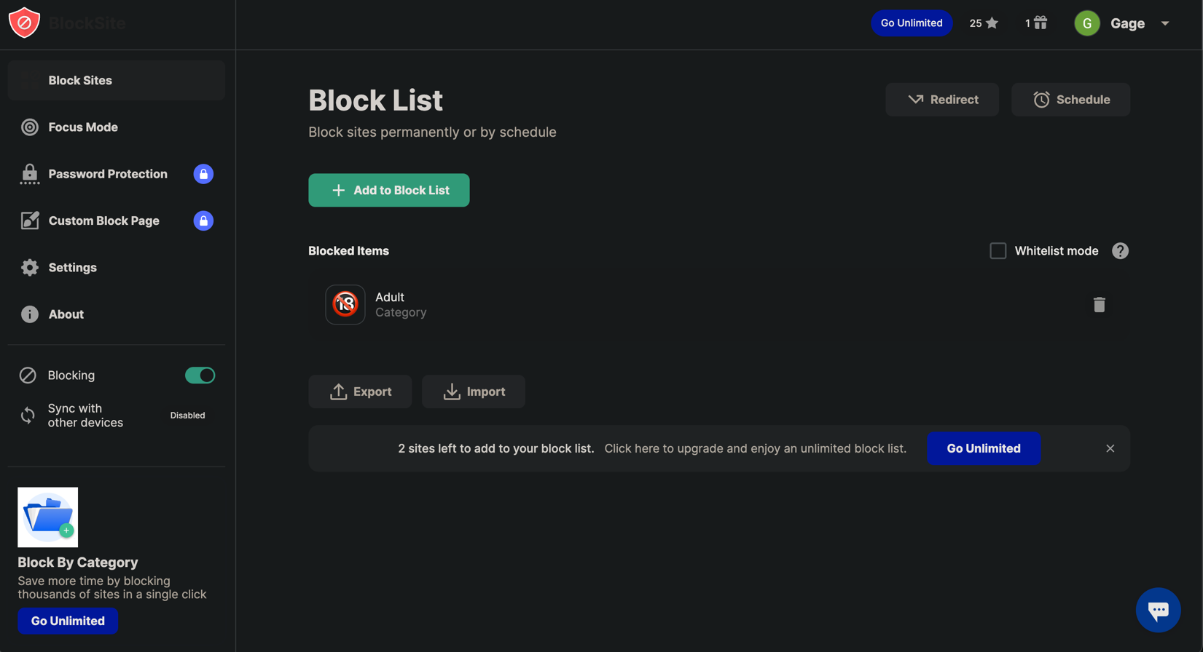

Figure 11: Blocklist dashboard.

This extension is an excellent indication of where StudySync can go with simple functionality and well-built UI. But highlights the need to maintain free access. Few users will pay for web extension functionality, and with our target demographic being so low, that risk cannot be taken.

#### 2.1.2.6 Toggl

Toggl is a time-tracking web extension and company, the most well-known application in web browser-based time-tracking solutions. It provides an all-in-one solution for time tracking for all digital tasks. For this comparison, we will only look at the web extension. The tool is a task tracker mainly used by professionals who must bill their time. However, it is so full of features that many different demographics use the tool to help increase their productivity. It provides a solution to PP-3.

It allows users to build a picture of the time they spend on a given task. They can categorize activities based on their current project, and power users can further adjust minor details to get genuinely accurate time tracking. The tool lets users output their time to reports or analytic dashboards, which can help paint a quality picture.

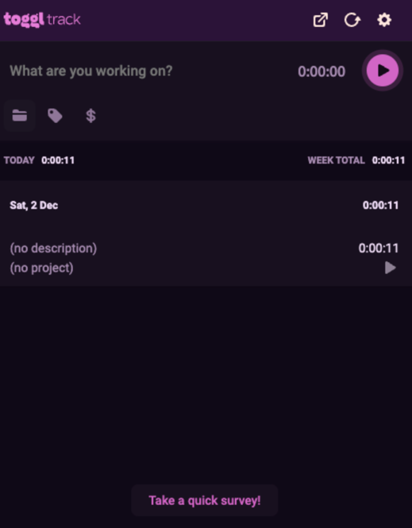

Figure 12: Toggle dropdown menu.

The extension has consistent branding and is great for power users. However, we do see it as an overfit for our project problems. Power users may be able to get great functionality out of the application, but it requires a high cost to set up, and our users have courses to focus on. The paywall also limits uptake as our market demographic prefers free-to-access extensions instead of ones behind a paywall.

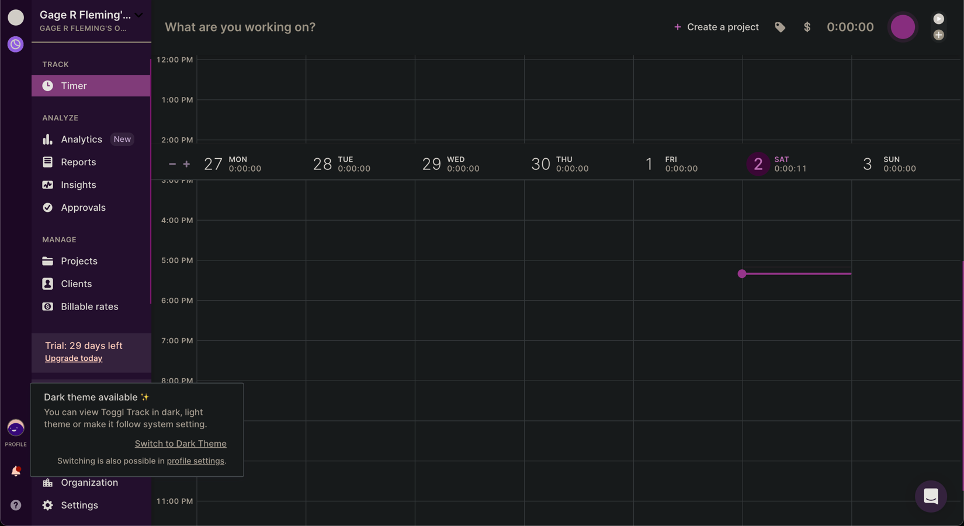

Figure 13: Toggle dashboard.

While Toggl is the gold standard for time tracking extensions, it again doesn’t quite fit our project problems quite as well as a proper solution would.

#### 2.1.2.7 STEEPLE

##### 2.1.2.7.1 Social

StudySync is focused on the demographic pertaining to the Bachelor of Computer Science offered on Coursera in partnership with the University of London. Within this demographic, many individuals exist, ranging from industry professionals to recent High School Graduates, all hailing from different countries. English is the language the degree is taught in; therefore, this language will be focused on.

##### 2.1.2.7.2 Technological

The extension is being produced for the Google Chrome web browser. Their policies and standards must be followed to ensure that StudySync is compatible with the browser and maintains a longstanding, healthy relationship. Current extension trends must also be considered to ensure our UI and functionality meet users' assumptions about web extensions.

##### 2.1.2.7.3 Economical

The extension is free and has no direct economic consequences to consider.

##### 2.1.2.7.4 Environmental

Digital technology accounts for 3-4 % of the world’s greenhouse gas emissions. While StudySync will provide little of that amount, it is vital to ensure efficient code is programmed and data storage is implemented correctly to reduce any carbon footprint StudySync would have on the environment.

##### 2.1.2.7.5 Political

Because the degree is offered within the UK, StudySync needs to follow current UK legislation and laws regarding digital services. Keeping in standard with these rules will enable the team to be reasonably sure that our extension is compliant globally.

##### 2.1.2.7.6 Legal

As mentioned above, StudySync must abide by UK and international law. However, due to the nature of the extension, these areas will be easy to navigate. For example, we are not storing data in a remote database for updates. Instead, it will be stored locally, with strict security practices. StudySync will need to focus more on the Coursera and University of London regulations and terms of use. Coursera has a rigorous data scraping policy. Therefore, we need to ensure how the extension collects data aligns with their terms of use. The program regulations will also play a role in guiding the legality of the extension.

##### 2.1.2.7.7 Ethical

The web extension is innocuous when considered within ethical ramifications. Helping students study better is a morally solid area. Combining this with a reliable development process and user involvement will create a product that puts the users first.

#### 2.1.2.8 SWOT

##### 2.1.2.8.1 Strengths

StudySync’s strengths will lie in its integration with and development for the Coursera platform. As mentioned above, many tools exist to enhance a student’s productivity. However, none have successfully improved the Coursera study experience to a level that meets our target demographic desires. The current web extensions don’t allow in-depth time tracking or, in many cases, accurate Coursera time tracking. The web blockers are mostly all blacklists or limiters; No quality whitelist exists for students to use.

StudySync will also offer a low barrier for entry by working “out of the box” and only requiring optional further work from the user if they want to go the extra length. The lack of a paywall will encourage more students to adopt the extension. The target demographic will see StudySync’s integration with Coursera and low barrier to entry as a valid solution to the project problems.

##### 2.1.2.8.2 Weaknesses

The main weakness the extension has is user attention. While StudySync is to have a shallow barrier to entry, a user still needs to be mindful of the tool to get valuable results out of it.

The Coursera time tracker will be based on the current Coursera page the user is on. If the user moves on to a different task, gets distracted or moves on from what the time tracker thinks the user is doing, the data will be invalid and inaccurate. Therefore, reminders, checks, and balances must be implemented to ensure the user is mindful of the tool. This must be done without aggravating the user, which brings us to our next point: uninstallation.

Many users desire to increase their productivity, but it’s easy to get frustrated when using any productivity tool, which can lead to rejection of the tool. For example, the whitelist web blocker can increase productivity during study sessions. However, if the user is unmotivated or in a poor mental headspace, they can reject the tool's guidance and either disable it or uninstall it. Thus, the user will need to have a certain level of motivation to use the tool effectively, a variable out of StudySync’s control.

##### 2.1.2.8.3 Opportunities

Refer to section 1.2.

##### 2.1.2.8.4 Threats

StudySync’s main threat is rejection by our target demographic. Solving our problem set is useless if no one uses the extension. Using an agile development process will keep our project in line with user expectations to ensure there is little gap in expectation between our team and the students.

Our team must also know the Coursera and University of London rules/regulations to ensure our extension is not problematic in these entities’ eyes. Another potential threat is the storage of user data on the application. Bad actors could sniff the data through the web browser if the local database is not secured correctly. User data is a crucial area to connect. One potential leak could lead to mass rejection of the product.

### 2.1.3 Project Problems and Objectives

* PP-1: Studying on Coursera is hindered by the complexity of the web browser.
* PP-2: Social media sites and other content sites easily distract from study sessions.
* PP-3: Coursera does not provide quality feedback regarding students' study habits.
* PO-1: Provide Coursera-integrated productivity tools that enhance study sessions.
* PO-2: Remove all website distractions from Coursera study sessions.
* PO-3: Effectively track 80% of students study time regarding tasks related to courses accessed via Coursera.



Figure 14: Product concept diagram.

### 2.1.4 Success Metrics

* SM-1: Completion of project within relation to guidelines set by module leaders.
* SM-2: User feedback indicates MVP is in line with user requirements.
* SM-3: Complete implementation of SRS.

### 2.1.5 Vision Statement

For computer science students enrolled in the program offered via Coursera and the University of London who need help to limit distractions to their studies, StudySync is a web extension that will provide a single point of access to study productivity tools. The web extension will use a whitelist to block all web traffic except for the URLs specified. The system will combine this with time-tracking analytics to provide actionable feedback on the quality of the user’s study sessions. The time tracker will track students' time spent studying during semesters in each class and each specific task within classes. This extension will increase students’ productivity and provide actionable statistics to help guide their study sessions. This enables students to create better study habits and become better students. Unlike the current productivity web extensions on the market, our product will integrate directly with the Coursera website, contain no paywall, and come with out-of-the-box functionality to combine into a low barrier to entry Coursera productivity extension.

### 2.1.6 Project Risks

* PR-1: The team’s other responsibilities (courses, careers) could limit the practical completion of daily tasks. (Probability = 0.7; Impact 9)
* PR-2: User intentions could limit time-tracking tools, leading to low usage statistics. (Probability 0.3; Impact 4)
* PR-3: Users may prefer to stick with their current productivity tools instead of adopting StudySync (Probability 0.5; Impact 3)

### 2.1.7 Project Assumptions and Dependencies

* PA-1: Users will use StudySync properly.
* PA-2: Users will allow StudySync to access website information and data.
* DE-1: StudySync needs access to the Coursera website to track study time effectively.
* DE-2: Users need to know what the time tracker is currently tracking to provide accurate analytics.
* DE-3: StudySync needs access to web browser URL searches.

## 2.2 Scope and Limitations

### 2.2.1 Major Features

* MF-1: View and update whitelist URLs and settings.
* MF-2: Store the whitelist in a persistent state on the local machine.
* MF-3: Block all URLs that are not present on the whitelist.
* MF-4: View and update time tracker settings
* MF-5: Track time spent on Coursera-related tasks.
* MF-6: Store the time tracking data in a persistent state on the local machine.
* MF-7: Display data analytics on a data dashboard.



Figure 15: Feature tree diagram.

### 2.2.2 Scope of the Development Process.

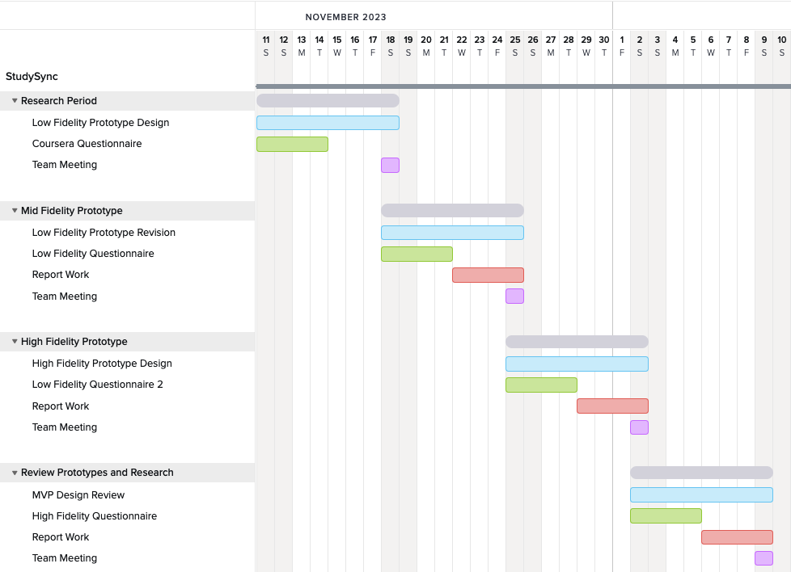

Figure : November 11 – December 9.

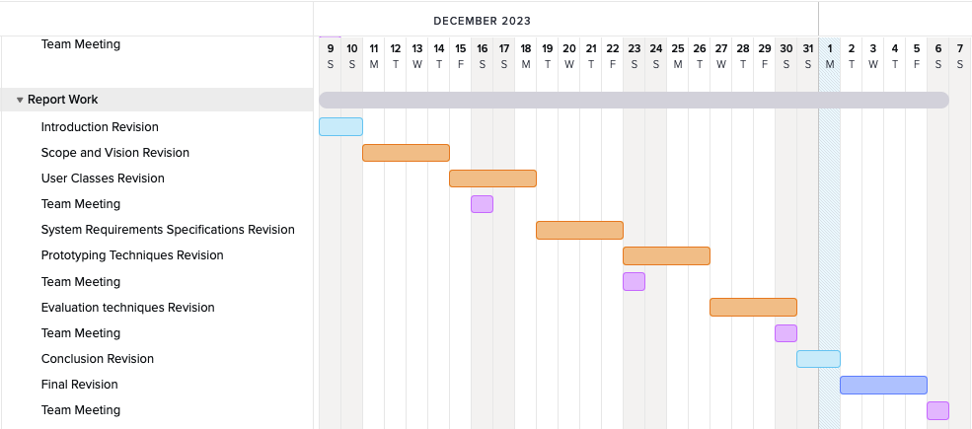

Figure : December 9 – January 7.

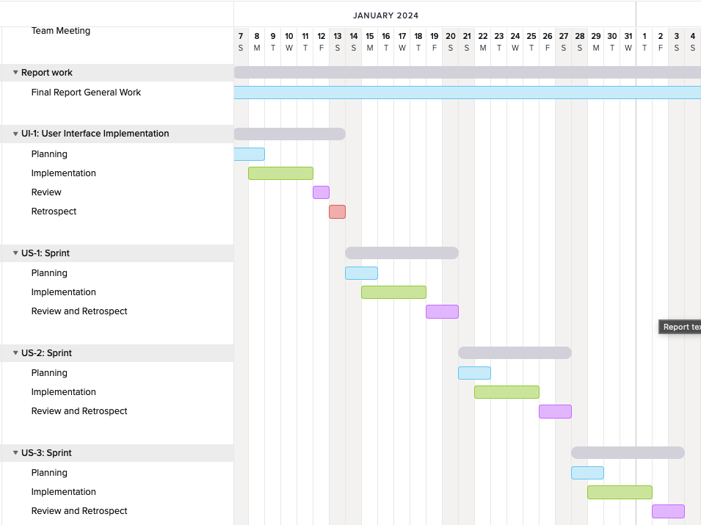

Figure : January 7 – February 4.

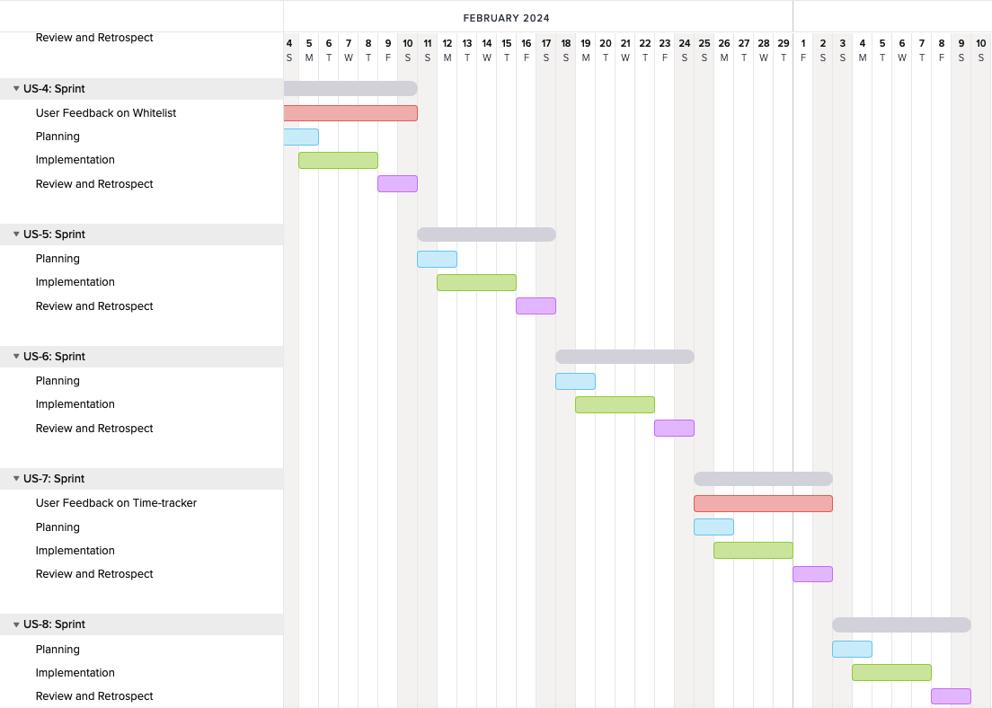

Figure : February 4 – March 10.

### 2.2.3 Limitations and Exclusions

* LI-1: No support will be provided for the Coursera mobile application.
* LI-2: Users must keep a Coursera page open for all time-tracking.
* EX-1: Further productivity tools (Pomodoro, AI, etc.) are out of scope for the initial release.

## 2.3 Project Context

### 2.3.1 Stakeholder Profiles

|  |  |  |  |  |
| --- | --- | --- | --- | --- |
| Stakeholder | Major Value | Attitudes | Major Interests | Constraints |
| University of London BSc Computer Science Students | Improved study productivity and time savings by limiting distractions. | Receptive to the project throughout development but not overly excited until the final product release. | Successful completion of courses. Implementation of quality study practices. | Extremely busy schedule may struggle to see value in looking into new tools. |
| StudySync (Team 68 Group 6) | Successful completion of CM2020. Combined with the development of essential project management skills. | Strong commitment and enthusiasm related to project development and delivery. | Successful completion of project and course. Quality implementation of well researched project. | Like the rest of the students, the team's busy schedule, combined with the course's timeline, limits the potential of the web extension. |
| Coursera | Improved ecosystem surrounding students and their study time. | No attitude regarding the project unless it breaks their terms of service. | Implementation of a quality online learning platform. Maintenance and inclusion of a quality community of learners. | Their terms of use need to be accounted for throughout the project lifecycle. |
| Dr. Sean McGrath and Module Tutors | No direct benefit. May use success or failure of the overall class to dictate future decisions regarding this module. | Strong enthusiasm throughout project development. Always willing to lend a helping hand. | Seeing student success throughout the course. Providing quality feedback to students. | Their grading scheme and oversight will directly affect what the end goal of the project is. |
| University of London | No direct benefit. Like above, class statistics are more useful to this stakeholder. | No direct attitude towards the project, unless it deviates from a standard delivery. Such as violating program regulations. | Seeing overall student success throughout courses. Fostering a quality environment for learning. | The program regulations will directly affect what can and will be produced by our team. |

### 2.3.2 Project Priorities

|  |  |  |  |
| --- | --- | --- | --- |
| Dimension | Constraint | Driver | Degree of Freedom |
| Features | All features scheduled for MVP must be fully operational. | Features correspond to a well-fit product for our project problems. Failure to implement features is a failure to solve the project problems. | If the initial scope and project are finished before the deadline. The team can create further functionality. |
| Quality | The team has agreed to a standard of work which matches upper second class – first class. | Team wished to do well in the class. | The schedule is more pressing than quality. If the quality needs to be adjusted to meet deadlines. Talks can begin then. |
| Schedule | The midterm submission date is January 8th, 2024. The final submission date will be in March. | NA | The schedule between submission deadlines can change based on iterative feedback and development. |
| Cost | The main finite resource the project is dealing with is time. Project needs to be finished within course defined deadlines. | NA | NA |
| Staff | Staff is limited to 5-person team assigned by the University. | NA | NA |

### 2.3.3 Deployment Considerations

The web extension will be deployed initially on the Google Chrome store to these users only. Our preliminary questionnaire indicates that 71% of the degree students use Google Chrome. The users must have an up-to-date Chrome browser to utilize the extension. As mentioned, Coursera policies and the University of London’s regulations will also guide how the extension is deployed. The team must also ensure the deployment matches the module leaders' project guidelines.

# 3 User Requirements

StudySync will respond to a single user’s actions, the user being the individual interacting with the web browser. This user will be a student studying for the BSc, Computer Science through Coursera, offered in collaboration with the University of London. Therefore, all user stories will be initiated by this student demographic. These user requirements were gathered and validated using the user requirements questionnaire in Appendix 7.1.3 and StudySync team elicitation.

|  |  |
| --- | --- |
| ID and Name: | US-1: As a student, I want to be able to toggle the whitelist blocker to change focus from study sessions to a different task. |
| Description: | The user either turns on or turns off the whitelist blocker functionality. |
| Trigger: | The user clicks on the whitelist toggle. |
| Preconditions: | PRE-1: StudySync is installed in web browser extensions. |
| Postconditions: | POST-1: The whitelist blocker is either on or off based on the toggle. |
| Normal Flow: | 1. **Toggle whitelist blocker.** 2. The user clicks on the whitelist toggle in the StudySync dropdown menu. 3. The whitelist is either set to on or off based on the toggle. |
| Frequency of Use: | Approximately ten times daily, assuming a study session occurs daily with techniques such as Pomodoro timing. |
| Assumptions: | Assume that users will never accidentally click this button and do not need to be warned when the whitelist will be toggled. |

|  |  |
| --- | --- |
| ID and Name: | US-2: As a student, I want to navigate to an allowed URL so that I can further my study session. |
| Description: | StudySync should validate all URLs entered by the user. The entered URLs should be compared against the whitelist to see if users can visit them while the whitelist is enabled. |
| Trigger: | The user navigates to a new URL through their web browser. |
| Preconditions: | PRE-1: The whitelist is enabled. |
| Postconditions: | POST-1: The user is either allowed to navigate to or rejected from navigating to the given URL. |
| Normal Flow: | **2.0 The user navigates to a URL.**   1. The user enters a URL into their web browser. 2. The user hits the search button. 3. The browser passes the URL to StudySync. 4. StudySync confirms the URL is on the whitelist. 5. StudySync allows access to the URL. |
| Alternative Flows: | **2.1 StudySync rejects the URL.**   1. Same steps 1-3 as above.   5. StudySync confirms the URL is NOT on the whitelist.  6. StudySync rejects access to the URL.  7. The user is prompted with a notification that the URL is not on the whitelist and, therefore, has been denied.  8. The user is prompted with an add to whitelist option. |
| Frequency of Use: | This user story will happen frequently when the whitelist is enabled. Users will navigate to many different websites during their study sessions. Some will be conducive to their studies, and others will not. |
| Other Information: | 1. Users should face little resistance when navigating to a website they wish to view for their studies. If the extension has too many roadblocks, users will uninstall it. 2. Users should be deterred from whitelisting distracting websites by displaying a quote or something inspirational when a page is blocked. |
| Assumptions: | Assume that users will be reasonably determined to allow the tool to help with study sessions. This means the user won’t bypass the whitelist and will be enough to set the user back on track. |

|  |  |
| --- | --- |
| ID and Name: | US-3: As a student, I want to whitelist a URL I need to visit so that I can study the material stored at that URL. |
| Description: | Users will need to navigate to many websites. The user must whitelist websites conducive to their study sessions. The user can manually enter the URL into the whitelist form. Or navigate to the URL in question and whitelist it from StudySync’s reactive response listed in the above user story. |
| Trigger: | The user either navigates to an unlisted URL or enters a URL into the whitelist form. |
| Preconditions: | PRE-1: The whitelist is enabled. |
| Postconditions: | POST-1: The URL is now whitelisted, and access has been granted. |
| Normal Flow: | **3.0 Whitelist URL through StudySync’s reactive response.**   1. The user completes steps 1-8 in US-2.2.1. 2. The user clicks on the “add to whitelist” option. 3. The URL is added to the whitelist. 4. The newly whitelisted page is loaded for the user to access. |
| Alternative Flows: | **3.1 Whitelist the URL by directly adding it to the whitelist form.**   1. The user navigates to the whitelist form page. 2. The user enters the URL to be whitelisted into the form. 3. The user clicks on the “save” button. |
| Frequency of Use: | The user will most likely whitelist many sites when using StudySync. However, this will most likely wane off after a while as the user allows access to the sites that are part of their usual study routine. This will then pick up once the user starts a new semester and requires access to fresh, differing websites. |
| Assumptions: | Assume the user will only whitelist sites which are conducive to their study sessions. |

|  |  |
| --- | --- |
| ID and Name: | US-4: As a student, I want to remove URLs from the whitelist so I can terminate access to a distracting website I needed to access briefly. |
| Description: | Users will sometimes need to navigate to potentially distracting websites. YouTube is an excellent example of where instructional videos can be found on the platform. The user may need to watch a video on there and choose to whitelist YouTube. However, after watching the video, the user will remove it from the whitelist to ensure the distracting portion of the website cannot be accessed. |
| Trigger: | The user deleted a URL from the whitelist form. |
| Preconditions: | PRE-1: The URL in question is stored on the whitelist form. |
| Postconditions: | POST-1: The deleted URL is removed from the whitelist.  POST-2: The deleted URL can no longer be accessed by the user. |
| Normal Flow: | **4.0 Remove a URL from the whitelist.**   1. The user navigates to the whitelist form page. 2. The user selects the URL(s) they wish to remove. 3. The user deletes them from the whitelist form. 4. The user clicks the “save” button. |
| Frequency of Use: | This will be functionality which is used more during revision. Users often navigate to potentially distracting websites to gain further insight into a complex topic. |
| Assumptions: | Assume the user will remember to remove the distracting website from the whitelist once their goals are complete. |

|  |  |
| --- | --- |
| ID and Name: | US-5: As a student, I want to study a course on Coursera and have that time tracked so I can gain insights into my study habits. |
| Description: | When a student navigates to Coursera and enters a course home page, StudySync will begin tracking the time spent within the courses catalogue and the finite tasks the user will complete. For example, if a user is studying course X by completing an assigned reading, StudySync will track that time as course X reading. |
| Trigger: | The user navigates to a course on Coursera. |
| Preconditions: | PRE-1: The extension is enabled.  PRE-2: The extension is allowed access to website data. |
| Postconditions: | POST-1: Study time is tracked and stored in a flat database. |
| Normal Flow: | **5.0 The user starts studying a course on Coursera.**   1. The user navigates to a Coursera course homepage. 2. StudySync begins tracking time spent in the course. |
| Alternative Flows: | **5.1 The user starts working on a task within a selected course.**   1. StudySync begins allotting time to a specific task under the current course. |
| Exceptions: | **5.0, 5.1 E1: the user opens multiple tabs.**   1. Only the tab which was first opened will be tracked by the extension. |
| Frequency of Use: | Most students will use the time-tracking portion of the extension daily. Coursera is the learning environment for the target demographic, and most visit the site daily. |
| Other Information: | 1. If the user clicks on a link in a Coursera course and it redirects to an external website, StudySync will continue to track the time as it was. |
| Assumptions: | Assume the users will remain relatively vigilant regarding what the extension is tracking. |

|  |  |
| --- | --- |
| ID and Name: | US-6: As a student, I want to view my time-tracking data in a digestible format to gain quick insights into my study habits. |
| Description: | Users will navigate to a data dashboard that will provide data visualizations and enable the user to gain actionable insights into their study patterns. |
| Trigger: | The user navigates to the data dashboard. |
| Preconditions: | PRE-1: Data has been collected by the time tracker. |
| Postconditions: | NULL |
| Normal Flow: | **6.0 User views the data dashboard.**   1. The user navigates to the data dashboard. 2. StudySync displays data visualizations based on time-tracking data. |
| Alternative Flows: | NULL |
| Exceptions: | 1. **E1 User has not yet tracked any data.** 2. The data dashboard displays a message indicating data needs to be collected before the dashboard can function. |
| Frequency of Use: | The data dashboard will be used infrequently, most likely weekly. This will allow users to look back on their weekly process and see if they notice any areas for concern. |
| Other Information: | 1. The data dashboard visualizations and data grouping will need to be decided on during the sprint for this user story. |
| Assumptions: | NULL |

|  |  |
| --- | --- |
| ID and Name: | US-7: As a student, I want to export my time tracker stats so that I can further explore the data using external tools. |
| Description: | Users may want to export their time-tracking data for further use in external tools. Therefore, an export option will be provided in CSV format. |
| Trigger: | The user clicks on the “export” button on the data dashboard. |
| Preconditions: | PRE-1: There is data stored in the extension. |
| Postconditions: | POST-1: A CSV file is created with the current time tracker data. |
| Normal Flow: | **7.0 Export the time tracker data to a CSV file.**  1. The user navigates to the data dashboard.   1. The user clicks on the “export” button. 2. StudySync downloads the CSV file to the user’s machine. |
| Alternative Flows: | NULL |
| Exceptions: | **7.0 E1: The user has not yet tracked data.**   1. No export button will be displayed. |
| Frequency of Use: | This will be an infrequent action used by StudySync’s power users only. Most users will find the data dashboard meets their needs. |
| Other Information: | 1. During this sprint, user feedback can change add or change the formats the data is exported to. |
| Assumptions: | NULL |

|  |  |
| --- | --- |
| ID and Name: | US-8: As a student, I want to adjust the time tracker settings so that I can tailor the extension to my study sessions. |
| Description: | Users may need to perform certain actions, such as indicating a new semester has started, deleting data or adding tasks to courses. This story will need to be fleshed out with users when this sprint comes around. |
| Trigger: | The user accesses the time tracker settings page. |
| Postconditions: | POST-1: Settings are updated. |
| Normal Flow: | (Confirm During Sprint) |
| Alternative Flows: |
| Exceptions: |
| Frequency of Use: |
| Other Information: |
| Assumptions: |

# 4 Software Requirements Specification

## 4.1 Introduction

### 4.1.1 Purpose

The SRS describes the functional and non-functional requirements for the initial release of StudySync. It is intended to guide the system's implementation and verify the web extension's correct functioning. All requirements are committed for the initial release.

## 4.2 Overall Description

### 4.2.1 Product Perspective

StudySync is a new web extension that aids Coursera students in their studies through a collection of productivity tools, including a whitelist web blocker and a time tracker dedicated to the Coursera platform. The following context diagram illustrates the initial release's external entities and system interfaces.

### 4.2.2 Operating Environment

* OE-1: StudySync shall operate correctly on the following web browsers: Google Chrome (all versions).

### 4.2.3 Design and Implementation Constraints

* CO-1: StudySync’s design, code and maintenance documentation shall conform to the *Google Webstore Program Policies,* [*https://developer.chrome.com/docs/webstore/program-policies*](https://developer.chrome.com/docs/webstore/program-policies)*.*
* CO-2: StudySync’s access to Coursera shall conform to *Coursera’s Terms of Use,* [*https://www.coursera.org/about/terms*](https://www.coursera.org/about/terms)*.*

### 4.2.4 Assumptions and Dependencies

* AS-1: The user is a student enrolled in the BSc in Computer Science offered on Coursera in partnership with the University of London.
* AS-2: The user will enter valid URLs into the whitelist form.
* DE-1: The user has allowed StudySync to access their website data.

## 4.3 System Features

### 4.3.1 Interact with the Extension via the Dropdown Menu

#### 4.3.1.1. Description

The user can interact with the extension via the dropdown menu. This will allow users to quickly toggle the whitelist web blocker and view their current time tracker stats. The dropdown will also enable users to navigate to the HTML pages provided by the extension.

#### 4.3.1.2 Functional Requirements

|  |  |
| --- | --- |
| Dropdown.Whitelist: | **Dropdown whitelist functionality** |
| .Toggle: | StudySync shall toggle the whitelist between on and off when the user clicks the toggle button. |
| .AddToWhitelist: | StudySync shall add the current domain name to the whitelist. |
| .Reload: | StudySync shall reload the current webpage. |
| .EditWhitelistButton: | StudySync shall redirect the user to the whitelist HTML page when the user clicks this button. |

|  |  |
| --- | --- |
| Dropdown.TimeTracker: | **Dropdown time-tracker functionality** |
| .Display: | StudySync shall display the current course and task being tracked along with the total time spent on the current task. |
| .StatsButton: | StudySync shall redirect the user to the data dashboard HTML page when the user clicks this button. |
| .SettingsButton: | StudySync shall redirect the user to the time-tracker settings HTML page when the user clicks this button. |

### 4.3.2 Navigate the HTML Pages via the Navbar

#### 4.3.2.1 Description

The user can navigate the extension HTML pages via a navbar, directing the user to the associated HTML page.

#### 4.3.2.2 Functional requirements

|  |  |
| --- | --- |
| Navbar: | **HTML pages navbar functionality** |
| .Whitelist: | When the user clicks on the whitelist navigation link, StudySync shall direct the user to the whitelist form page. |
| .DataDashboard: | When the user clicks on the data dashboard navigation link, StudySync shall direct the user to the data dashboard page. |
| .TimeTrackerSettings: | When the user clicks on the time-tracker settings navigation link, StudySync shall direct the user to the time-tracker settings page. |

### 4.3.3 Edit the Whitelist Form

#### 4.3.3.1 Description

The user can adjust the URLs to be allowed by the whitelist web blocker. They can add and remove URLs via the form and save the updated list by clicking the save button.

#### 4.3.3.2 Functional Requirements

|  |  |
| --- | --- |
| Whitelist.Form: | **Editing whitelist form** |
| .AddURL: | StudySync shall allow the user to enter a new URL into the whitelist form. |
| .RemoveURL: | StudySync shall allow the user to remove a saved URL. |
| .SaveButton: | When the user clicks the save button, StudySync shall save the current whitelist form. |

### 4.3.4 Whitelist all Attempted URL Queries

#### 4.3.4.1 Description

StudySync will automatically verify that all URL requests made by the web browser are allowed to reach the user. The extension will verify the domain name against the whitelist form.

#### 4.3.4.2 Functional requirements

|  |  |
| --- | --- |
| Whitelist.Verify: | **Verify user can access a given URL** |
| .RetrieveURL: | StudySync shall retrieve all URL queries made by the web browser. |
| .CompareURL: | StudySync shall compare all URL query domain names made by the web browser with the whitelist. |
| .Allow: | If the Domain name is on the whitelist, StudySync shall allow access to the website. |
| .Deny: | If the Domain name is not on the whitelist, StudySync shall not allow access to the website. |
| .Alert: | StudySync shall alert the user via a custom URL page indicating the requested URL has been blocked. |

### 4.3.5 Track Coursera Study Time

#### 4.3.5.1 Description

When a user has a URL open with the domain name coursera.org, StudySync will automatically track the time the user spends studying a course on the Coursera platform. The extension will track the time spent on the course and the current task.

#### 4.3.5.2 Functional requirements

|  |  |
| --- | --- |
| TimeTracker.Track: | **Track time spent studying on Coursera** |
| .Validate: | StudySync shall validate the domain name of all URLs to check if the user is on a Coursera domain. |
| .CheckCourse: | StudySync shall confirm if the full URL is related to a course selected by the user in the time tracker settings. |
| .TrackCourse: | If the user is currently in a course Coursera section. StudySync shall start tracking time spent in the course. |
| .TrackTask: | If the user is within a given task, then StudySync shall track the time spent on the current task shown by the URL. This will be tracked under the current course the user is in. |
| .StoreData: | StudySync shall automatically store the time-tracker data locally in a flat format. |

### 4.3.6 View Time-Tracker Stats on Data Dashboard

#### 4.3.6.1 Description

The user can gain insights into their Coursera study habits via a data dashboard to visualize the time-tracker data. The user can break the data down by the overall semester, courses, and further details to be determined based on user feedback.

#### 4.3.6.2 Functional requirements

|  |  |
| --- | --- |
| TimeTracker.DataDashboard: | **Display the data collected by the time tracker.** |
| .Group: | StudySync shall organize the data into logical separations. |
| .Semester: | StudySync shall display data visualizations based on the current semester's time-tracking data. |
| .Course: | StudySync shall display data visualizations based on the currently selected course. |
| .SelectCourse | StudySync shall allow the user to select the current course to be analyzed on the data dashboard. |
| .TBD: | User feedback can guide further visualizations when this is implemented. |
| .StoreData: | StudySync shall automatically store the time-tracker data locally in a flat format. |
| .Export: | StudySync shall allow the user to export the time-tracker data to CSV format. |

### 4.3.7 Adjust Time-Tracker Settings

#### 4.3.7.1 Description

The user will need to adjust specific requirements and information for the time-tracker. While we know the user will need the option to start a new semester, this system requirement must be fleshed out during the sprint.

#### 4.3.7.2 Functional requirements

|  |  |
| --- | --- |
| TimeTracker.Settings: | **Adjust the time-tracker settings** |
| .StartNewSemester: | When the user clicks this button, StudySync shall start a new tracking period by deleting old data. |
| .TBD: | The settings page will need to be fleshed out during the sprint related to it. User feedback will need to be gathered to ensure the time-tracker is meeting their needs. |

## 4.4 Data Requirements

### 4.4.1 Logical Data Model



Figure : Logical Data Model.

### 4.4.2 Data Dictionary

|  |  |  |  |
| --- | --- | --- | --- |
| Data Element | Description | Composition or Data Type | Length |
| Course | A course provided by Coursera. | String | 50 |
| Task | A task to complete indicated by an associated course. | String | 50 |
| Course Time | The amount of time the user has spent with a given course opened on their web browser. | Time | DD:HH:MM |
| Task Time | The amount of time the user has spent with a given courses task opened on their web browser. | Time | DD:HH:MM |
| URL | A given websites address. | String | 250 |
| Domain Name | A given website's domain name. | String | 100 |
| Semester Start Date | The start of the current semester as selected by the user. | Date | DD/MM/YYYY |

### 4.4.3 Reports

|  |  |
| --- | --- |
| Report ID | StudySync-Report-1 |
| Report Title | Time Tracker Data |
| Report Purpose | The user wants to download time tracker data stored up to the current point in time. Allowing them to further analyze the data with external tools. |
| Data Sources | The time-tracker flat-file database. |
| Frequency and Disposition | The report is generated on demand by a user. Data in the report is static. The report is exported in CSV format. |
| Report Body | Fields shown and column headings:  Course  Task  Time  All data for the current semester will be exported and sorted by course alphabetically. |
| Security Access Restrictions | The user can only view the data stored on their local machine. |

### 4.4.4 Data Acquisition, Integrity, Retention, and Disposal

* DA-1: StudySync shall collect input data from the user via the whitelist form, dropdown menu, and time-tracker settings page.
* DA-2: StudySync shall collect data automatically from any URL with coursera.org as the domain name.
* DR-1: StudySync shall allow the user to dictate how long the data is stored.3
* DD-1: StudySync shall allow the user to delete all data from within the extension.

## 4.5 External Interface Requirements

### 4.5.1 User Interfaces

* UI-1: StudySync shall conform to user interface standards set by *Google* [*https://developer.chrome.com/docs/extensions/develop/ui*](https://developer.chrome.com/docs/extensions/develop/ui)*.*
* UI-2 Interface design shall conform to user feedback acquired via questionnaires.

### 4.5.2 Software Interfaces

* SI-1: StudySync shall communicate with the web browsers through a programmatic interface.
* SI-2:StudySync shall store data through Google Chrome's storage API: [*https://developer.chrome.com/docs/extensions/mv2/reference/storage?hl=en#storage_areas*](https://developer.chrome.com/docs/extensions/mv2/reference/storage?hl=en#storage_areas)*.*

## 4.6 Quality Attributes

### 4.6.1 Usability

* USE-1: StudySync shall enable users to reach a specified page within two clicks.

### 4.6.2 Performance

* PER-1: StudySync shall have a minuscule effect on web pages and overall browser loading times.

### 4.6.3 Security

* SEC-1: StudySync shall only allow the web browser user to view stored time-tracker data.
* SEC-2: StudySync shall not permit any website access to the user data.

### 4.6.4 Safety

SAF-1: For permanent actions like deleting data, StudySync shall confirm if the user wants to proceed.

# 

# 5 Prototypes

## 5.1 Low-Fidelity Prototypes

### 5.1.1 Prototype One

The prototype took heavy inspiration from the applications the team researched. It implemented clear and straightforward UI choices that allow a user to interact with the functionality of the web extension easily. The dropdown menu displays the most important options to the users, enabling them to navigate the web pages. The whitelist page contains a form with all of the allowable URLs. The form takes up most of the page to ensure the form is highlighted. The data dashboard then breaks down the data into visual chunks that focus the user on what they are looking for. Lastly, the settings page follows a style similar to the data dashboard. Visual distinction is provided in these images through simple white space separation. StudySync is meant to be a simple extension that integrates seamlessly with Course, and this prototype is our first interpretation of this idea.



Figure : Dropdown Menu.

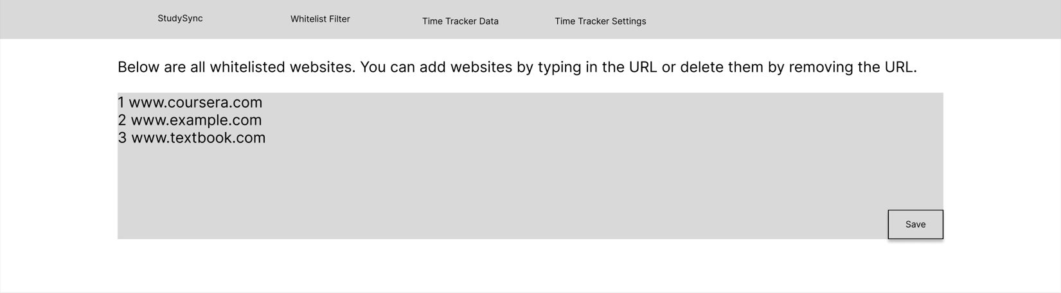

Figure : Whitelist Page.



Figure : Data Dashboard Page

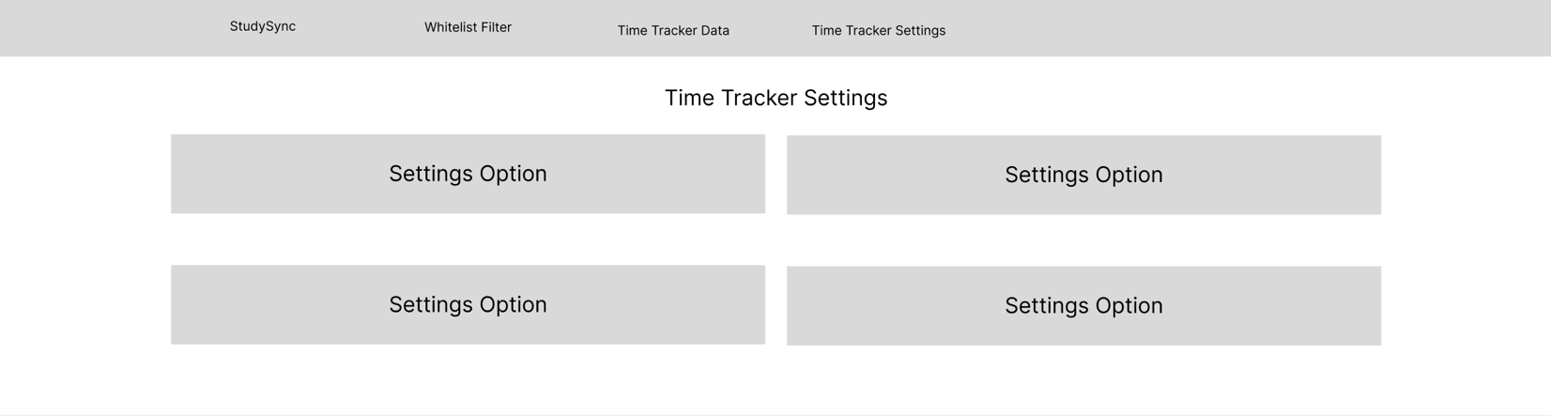

Figure : Settings Page.

### 5.1.2 Prototype Two

This prototype tried to fit all functionality with a single dropdown menu in contrast to the above. This is to keep the functionality on a Coursera page and remove the potential navigation from Coursera. We wanted to see how users would react to a design that followed this implementation. Our market research indicated a page-based layout is the standard for these extensions. Still, with the focus on Coursera integration, we felt it was vital to test some ideas that keep Coursera as the focus.

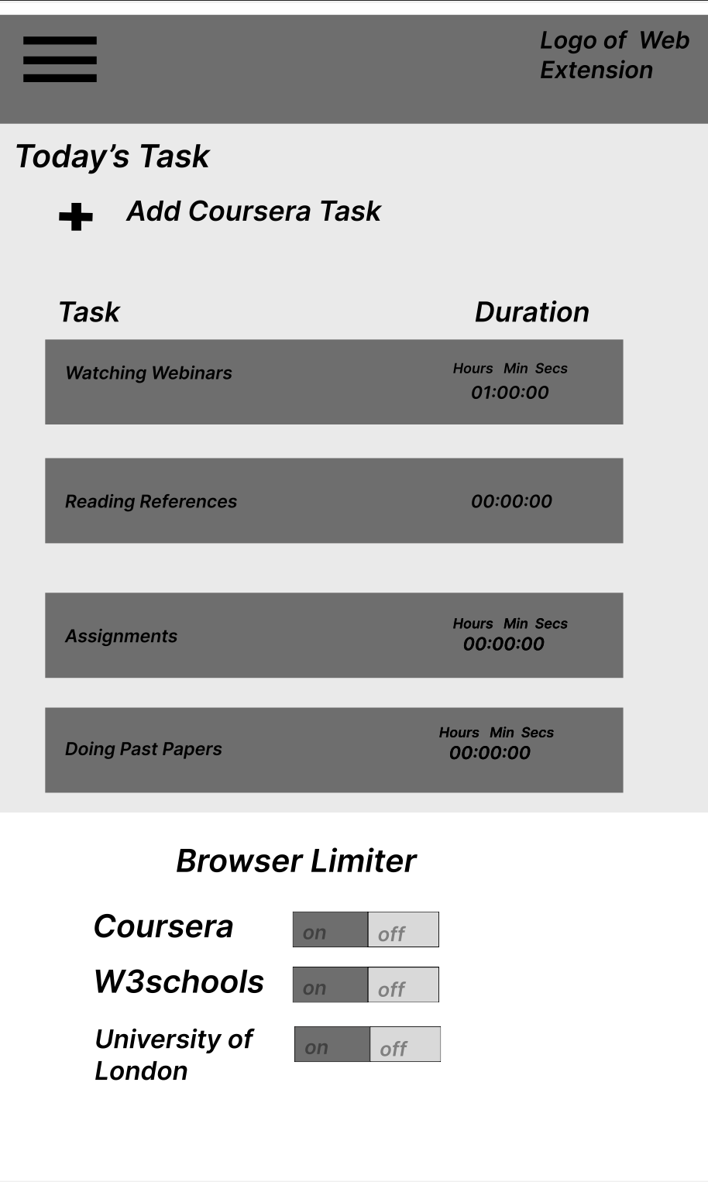

Figure : Dropdown Menu.

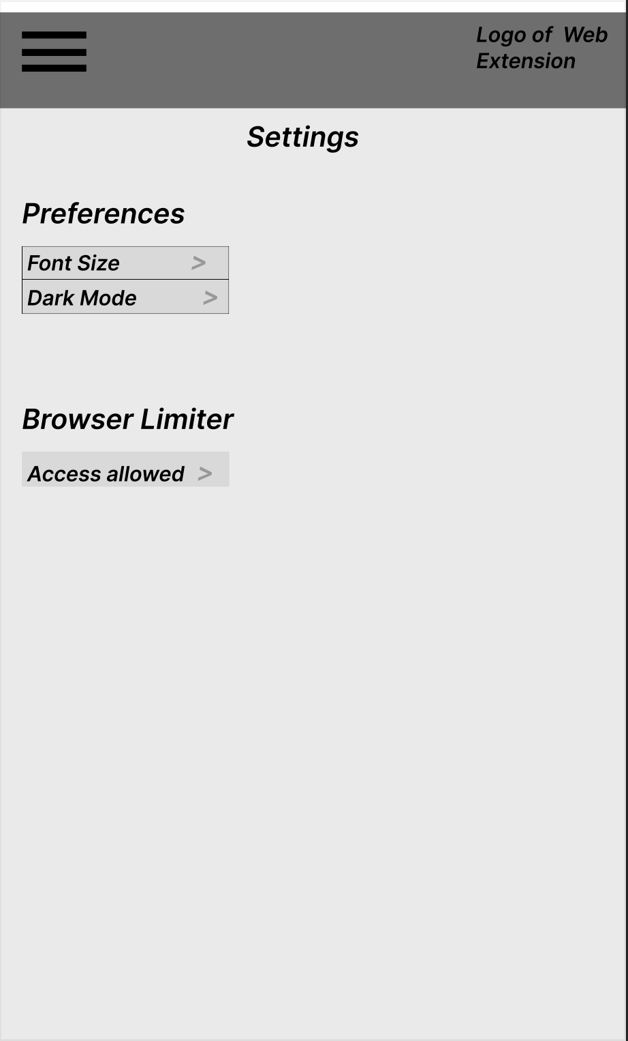

Figure : Dropdown Menu Settings.

### 5.1.3 Prototype Three

The final prototype was to test how simple we could keep the extension. It tried to emulate some of the simplicity we saw in the market research. We also wanted feedback from users regarding complexity. The first prototype was the one we thought functioned best. However, we wanted to test our assumptions that users would want a similar extension to what is currently on the market. This prototype, in particular, keeps everything in a single dropdown menu, challenging the idea of a page-based layout and focusing on simplicity.

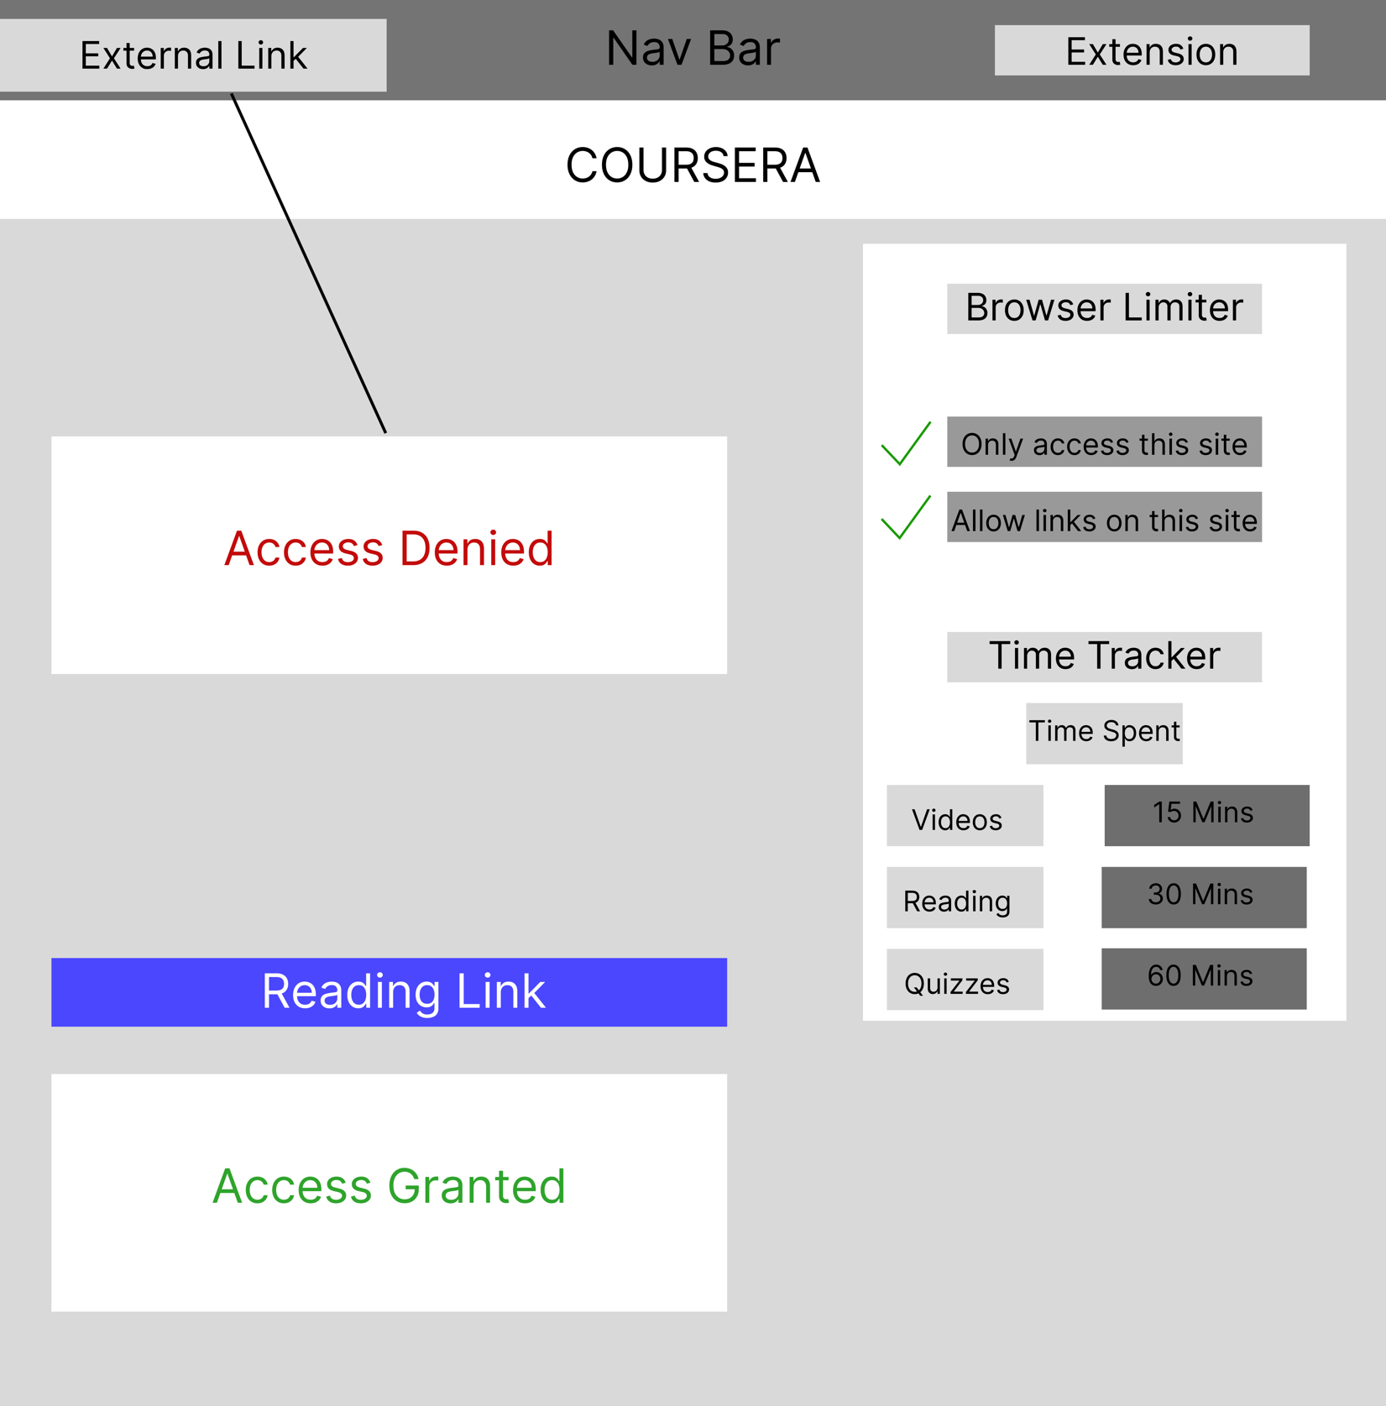

Figure : Dropdown menu.

## 5.2 Low-Fidelity Prototype Questionnaire

With the low-fidelity prototypes produced, we need user feedback. The questionnaire found in Appendix 7.1.2 was designed and sent to our user demographic to get feedback on the prototypes. As was expected, prototype one was the most popular one and validated our assumptions of what users were looking for. However, prototype two also had a lot of positive feedback and insight provided by the users. Thus, StudySync decided to combine the functionality of the two for a high-fidelity prototype and make slight adjustments to the overall design to meet the expectations of the feedback.

## 5.3 High-Fidelity Prototype

StudySync produced a high-fidelity prototype by eliciting feedback on low-fidelity prototypes. This was implemented using JavaScript and functions as a basic prototype for users to interact with and get a feel for the product. The first and second low-fidelity prototypes were combined to produce the overall design. The user feedback was also combined with our system requirements and user stories to ensure the design met our understanding of what users seek. This design will be tested via another user questionnaire; however, this design is a great starting point for meeting the expectations of our stakeholders and provides the basis for a valid solution within our problem space.

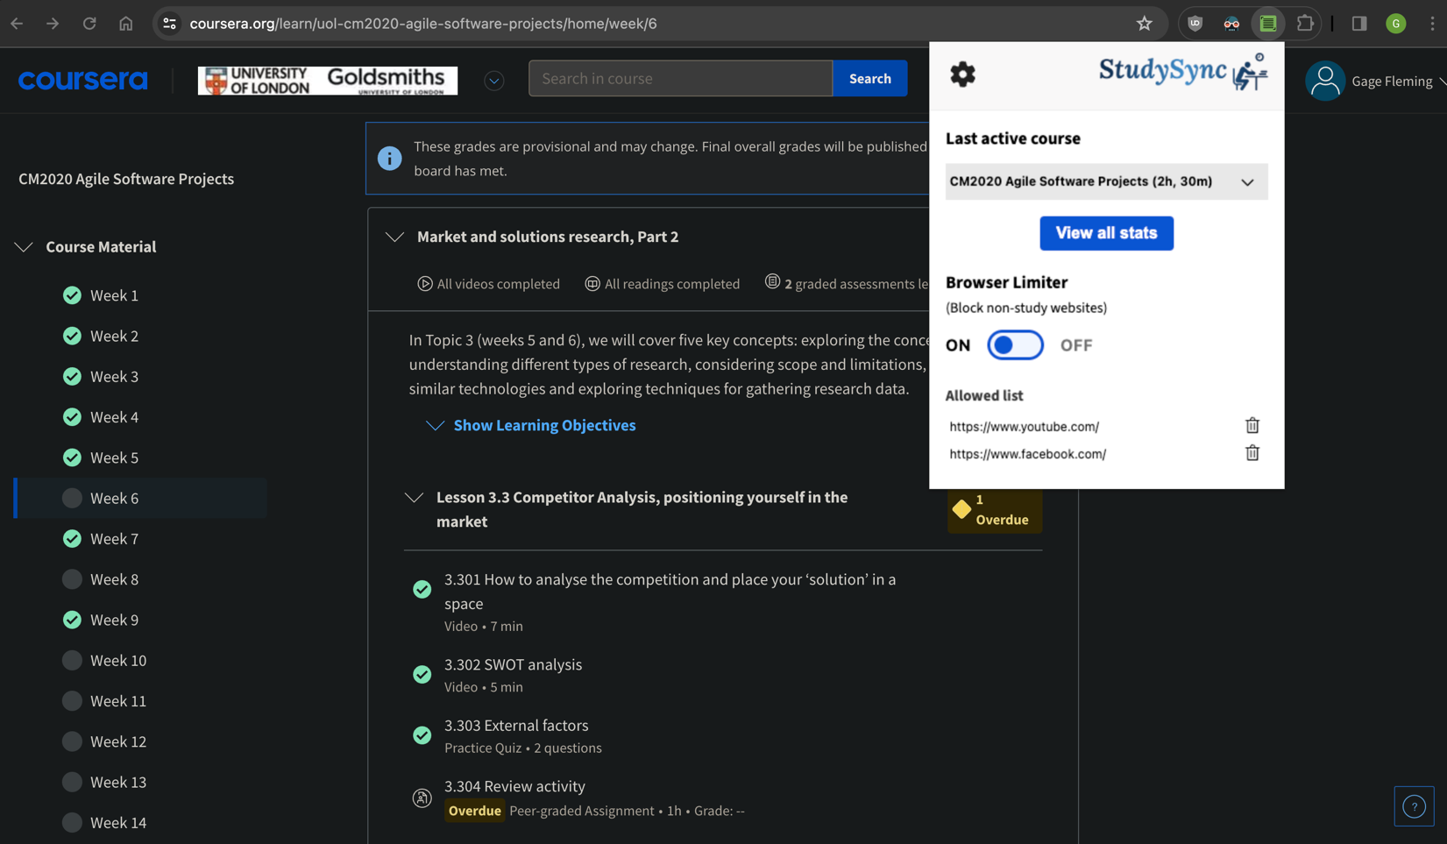

Figure : Dropdown Menu.

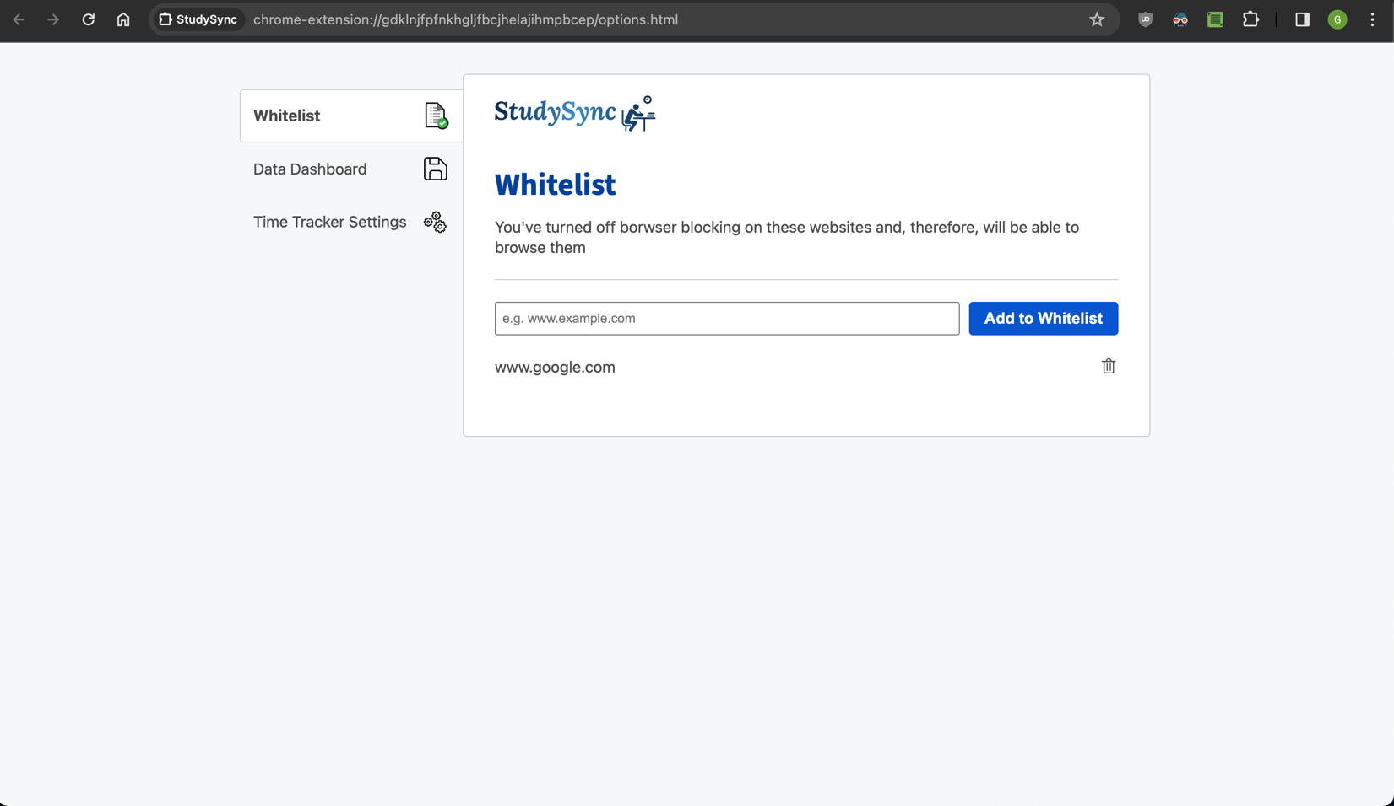

Figure : Whitelist Page.

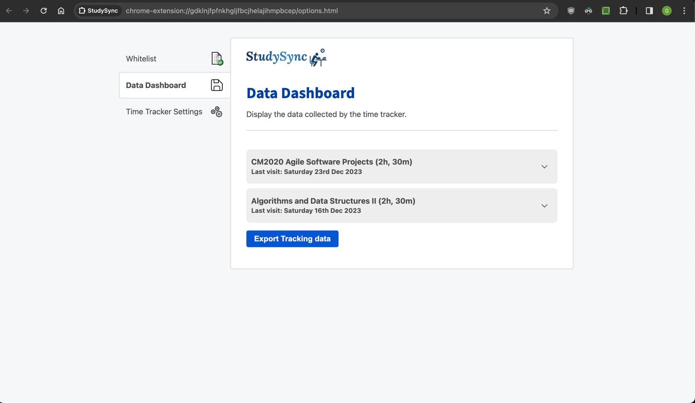

Figure : Data Dashboard Page.

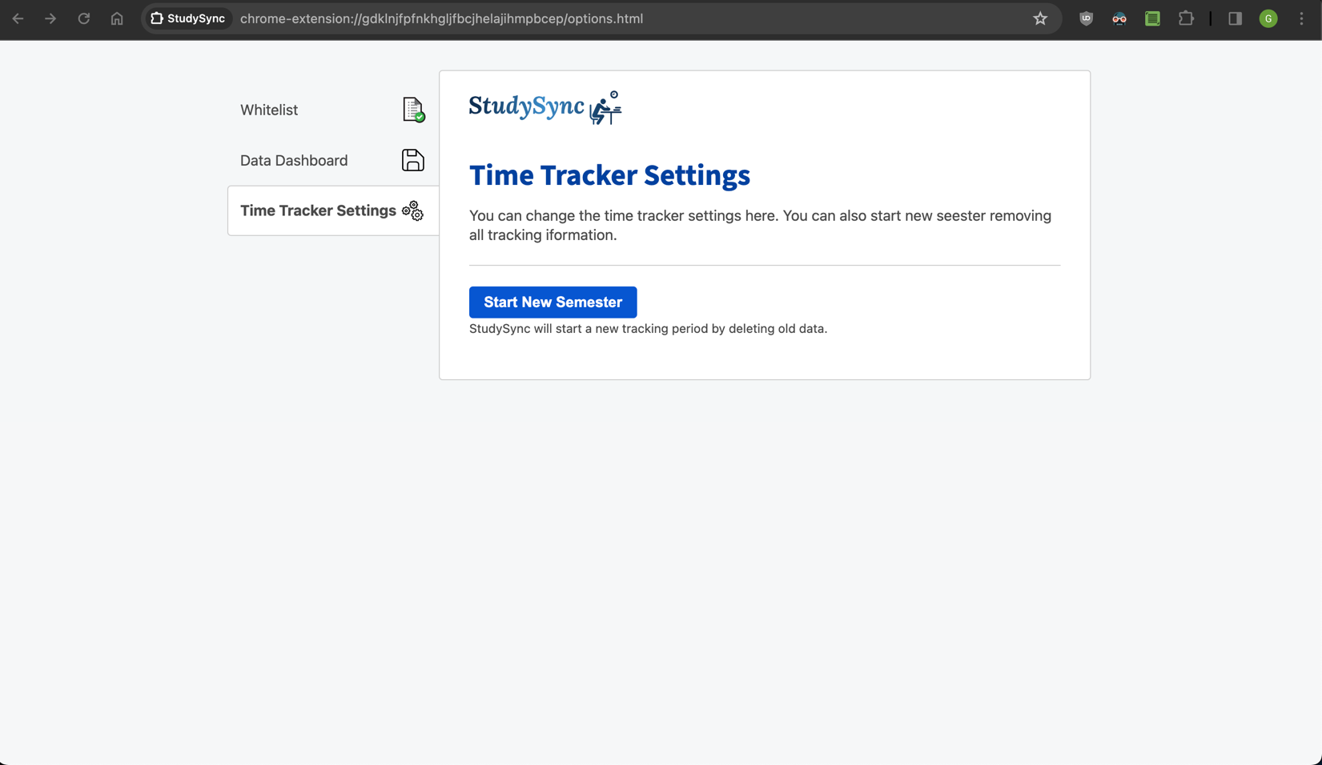

Figure : Settings Page.

## 5.4 High-Fidelity Prototype Questionnaire

The questionnaire validated the direction we took with our high-fidelity prototype. The users responded well to the design decisions and indicated the extension was easy to use and learn. Confirming we produced a low barrier to entry design that should flow into great functionality. Users indicated the pages were good features and did not have too many issues with the design. This is a positive step as the team heads into implementing the functionality.

# 

# 6 Conclusion

Through quality research, elicitation, and requirements development, the team at StudySync has produced a project proposal that effectively outlines the work needed to complete the web extension. The proposal follows industry standard practices in formatting and requirements elicitation. We are particularly proud of how we identified and solved specific problems related to a niche group of users. A quality solution has been proposed, and we are pleased to be working on this extension. The project is on track to produce an MVP by the final deadline. The functional requirements and agile software plan give the team enough time and guidance to deliver the proposal effectively.

The team had to work through many of these requirements ad hoc as this was the majority of the team’s first time tackling a project of this scope and size. Therefore, weaknesses were bound to pop up. The team struggled to ask quality questions in some questionnaires as we were not used to involving users in the development process. For the final report, we want more quality questions and a further connection with the product's users. The team also struggled to maintain a quality time balance as the other coursework and life responsibilities got in the way. Luckily, the planning gave us enough time to account for this, but we feel this should be limited during the final section of this course. Lastly, the team struggled to get on the same page with some sections. The remote nature of the class posed a significant hurdle to getting this project done. Students range from very different time zones, and connecting was difficult.

While problems arose and adjustments had to be made, we are confident a quality project proposal has been made and look forward to implementing the complete solution.

# 7 Appendix

## 7.1 Questionnaires

### 7.1.1 Coursera Questionnaire

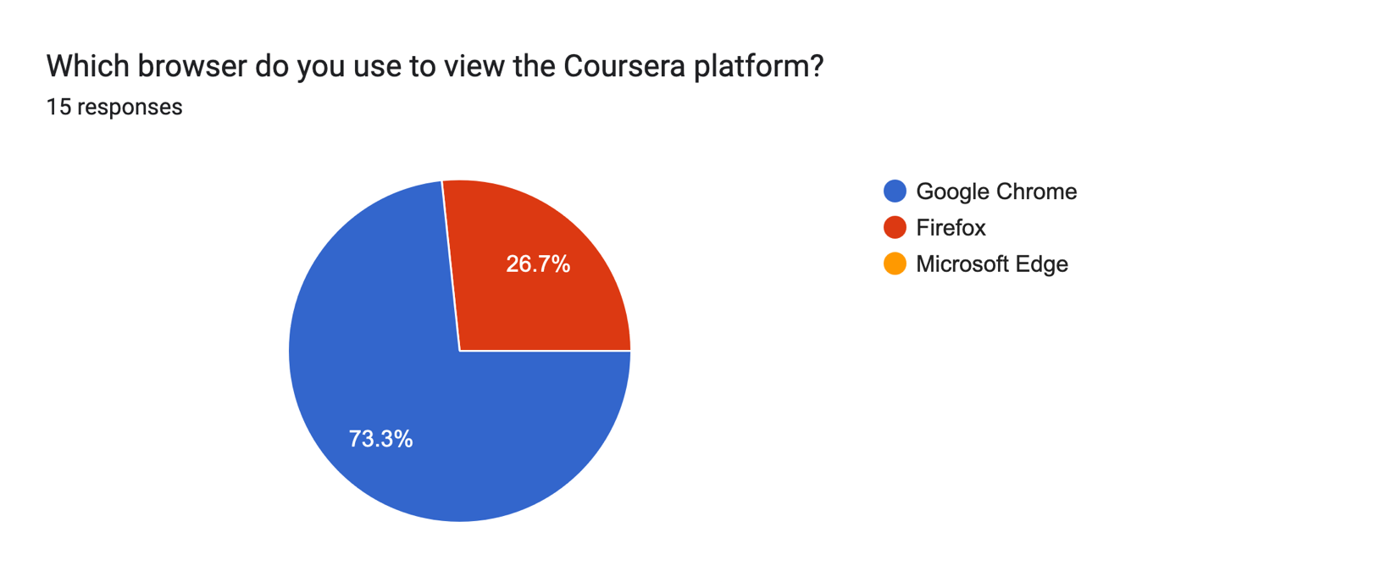

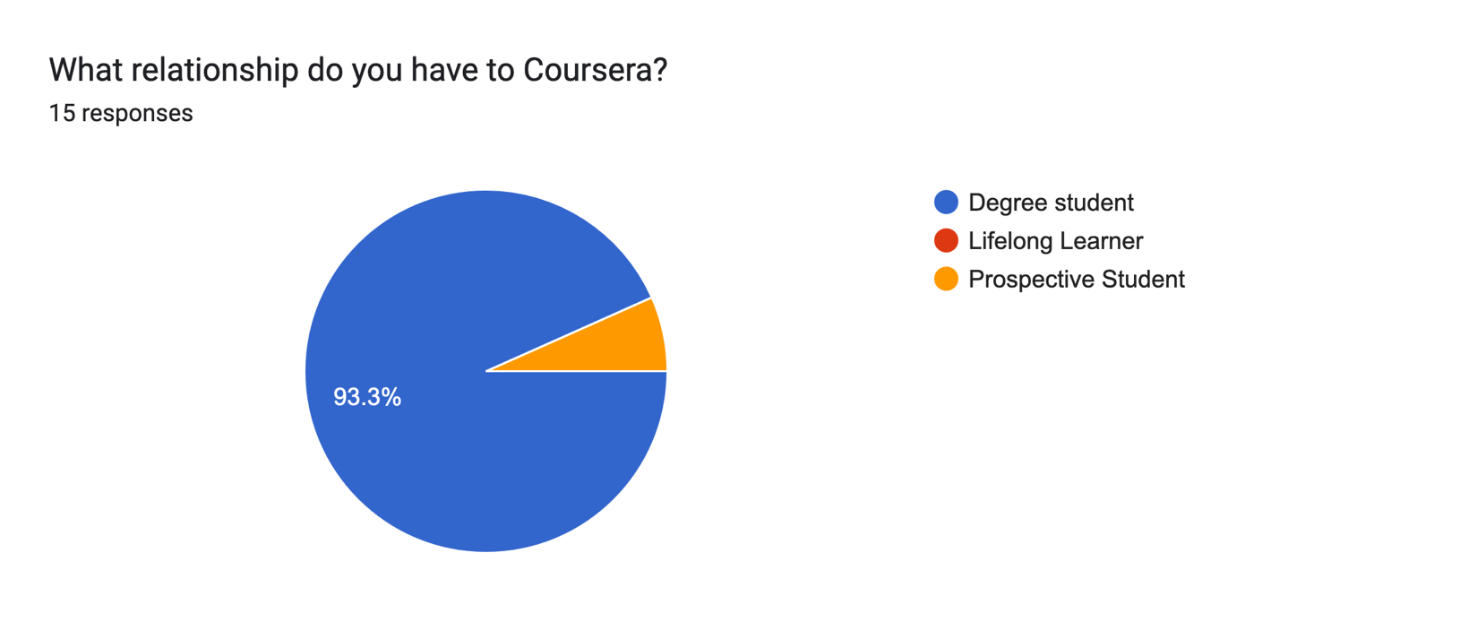

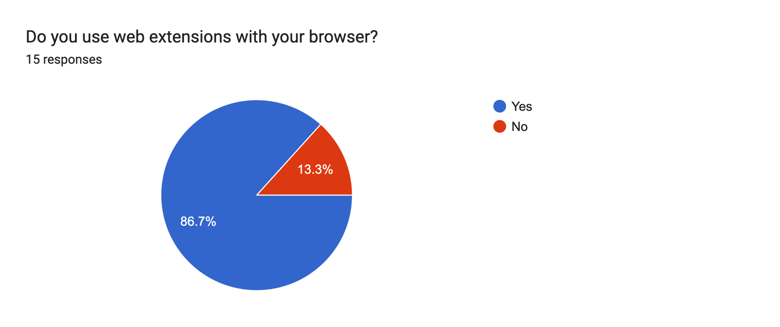

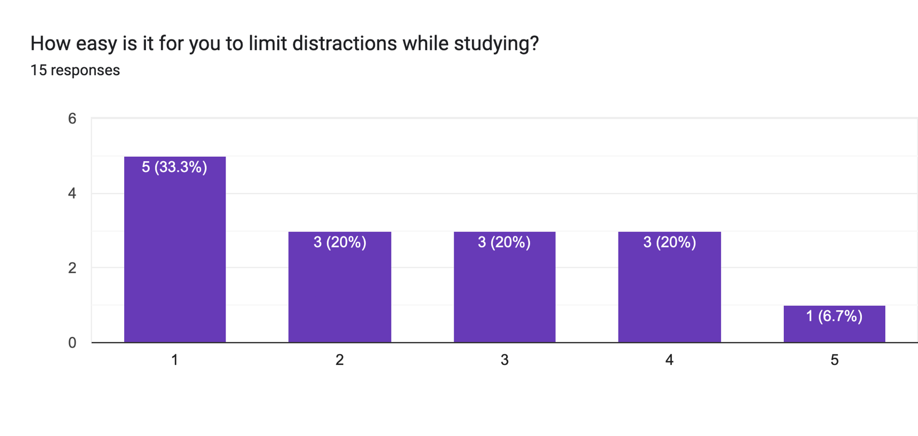

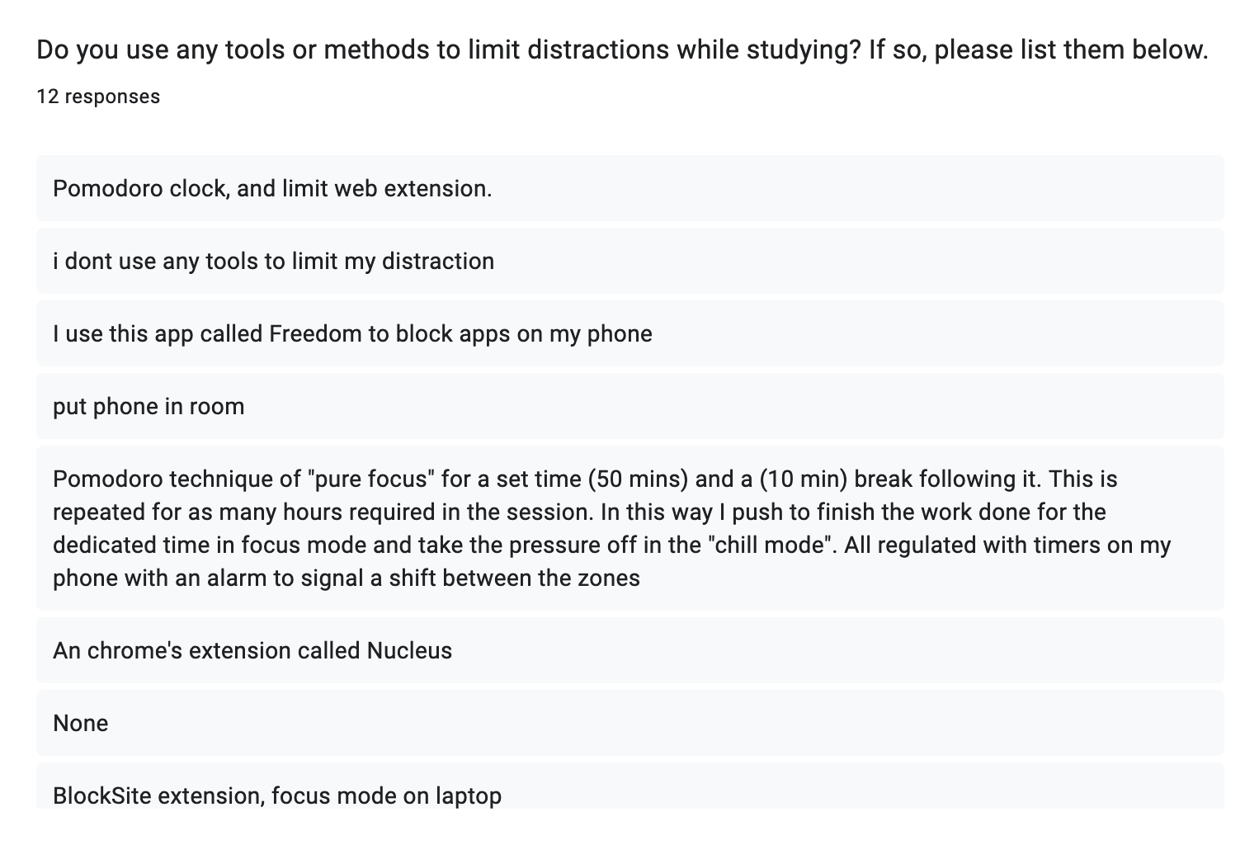

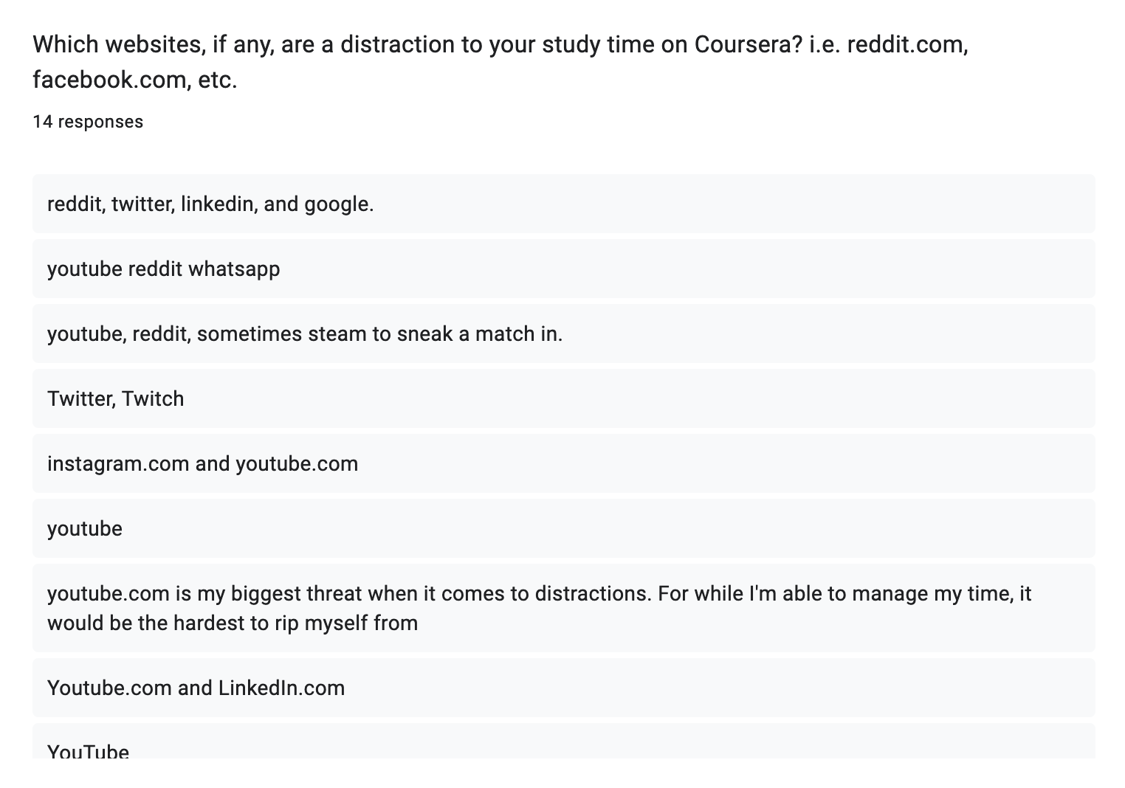

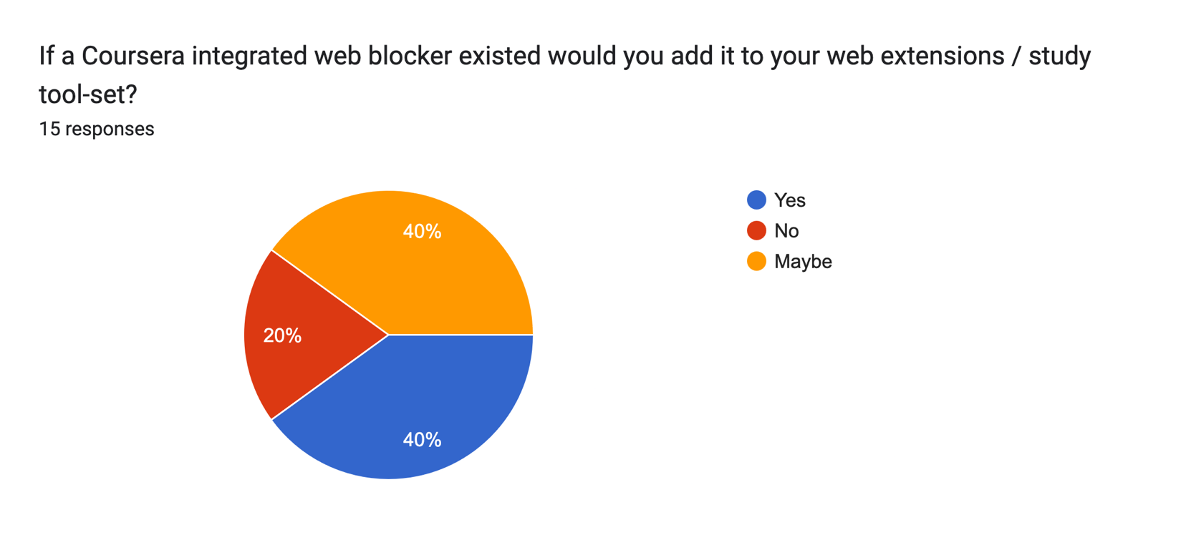

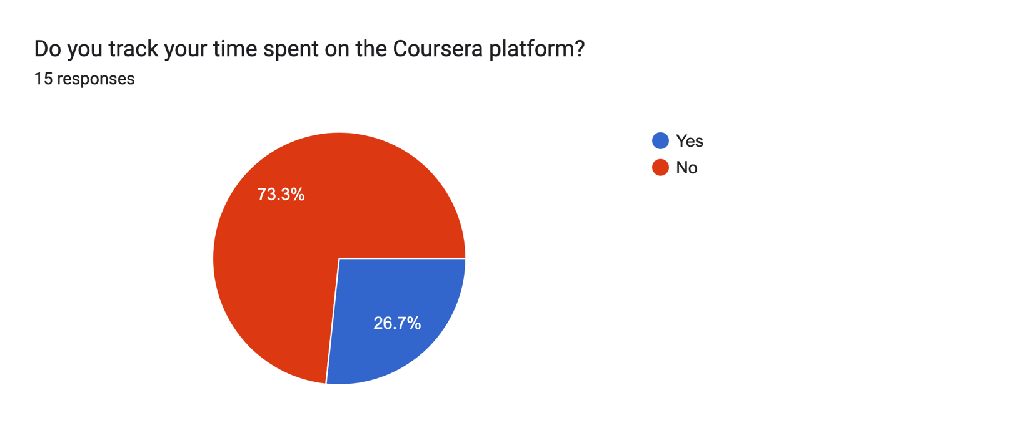

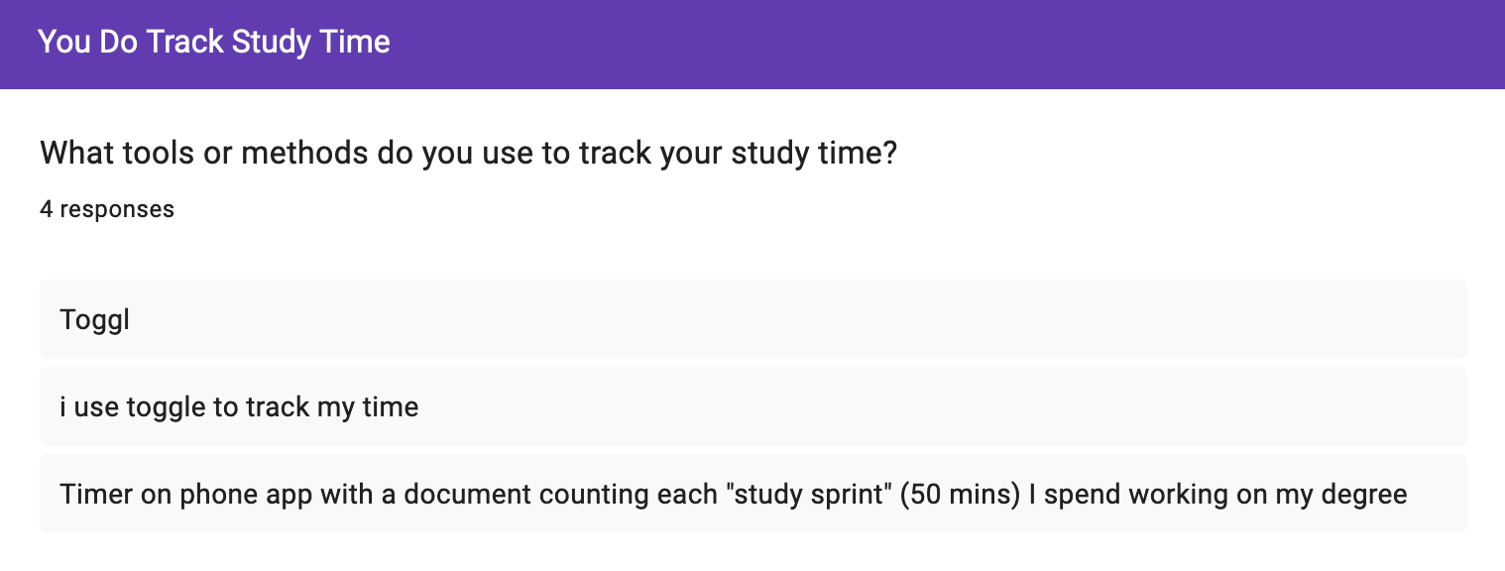

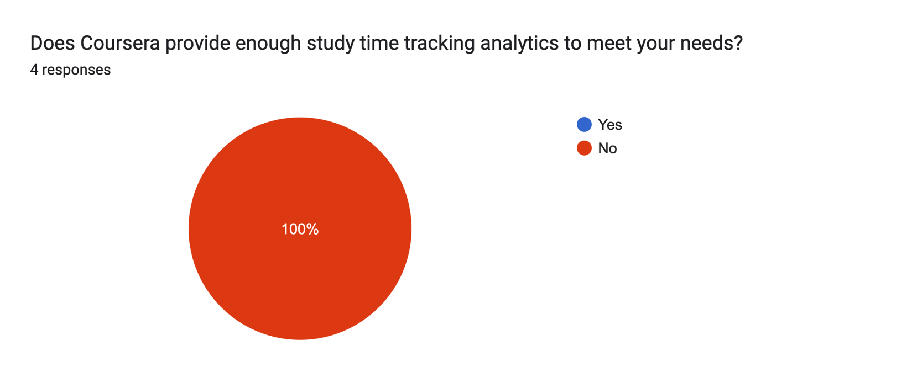

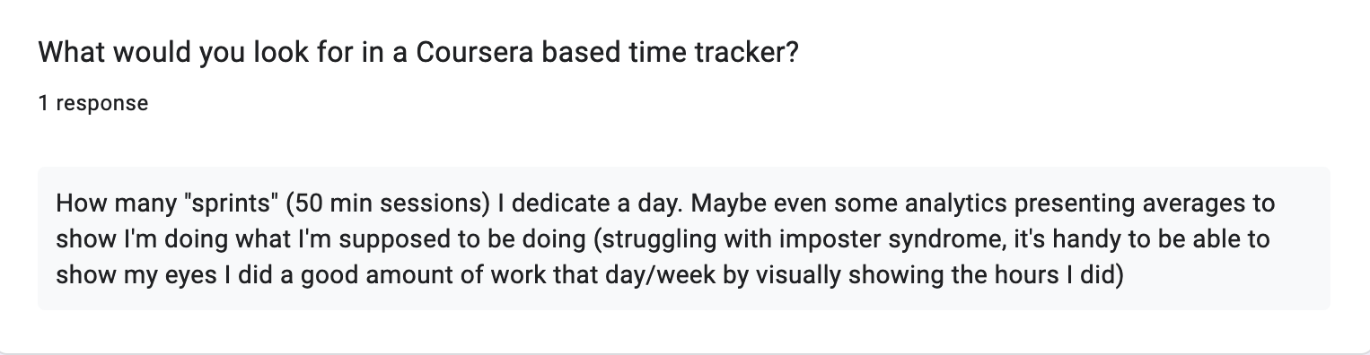

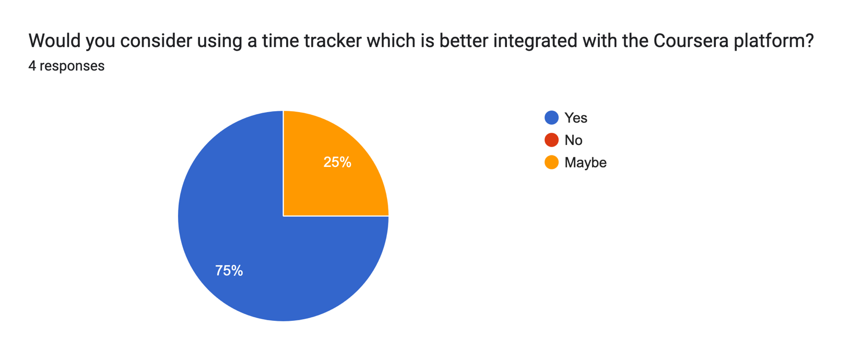

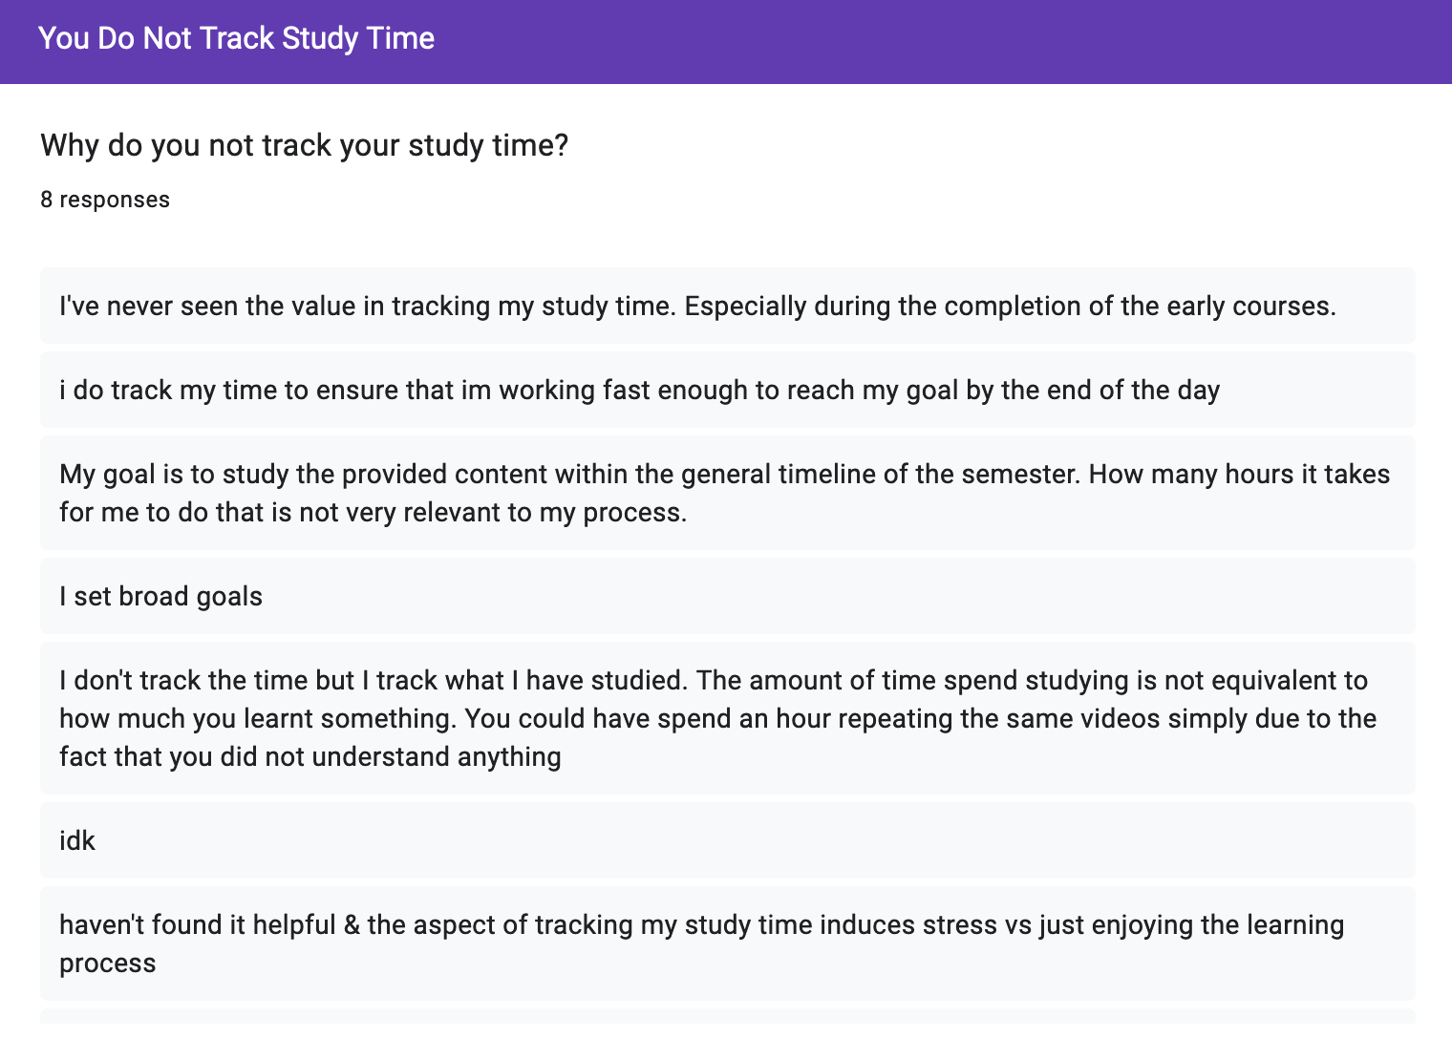

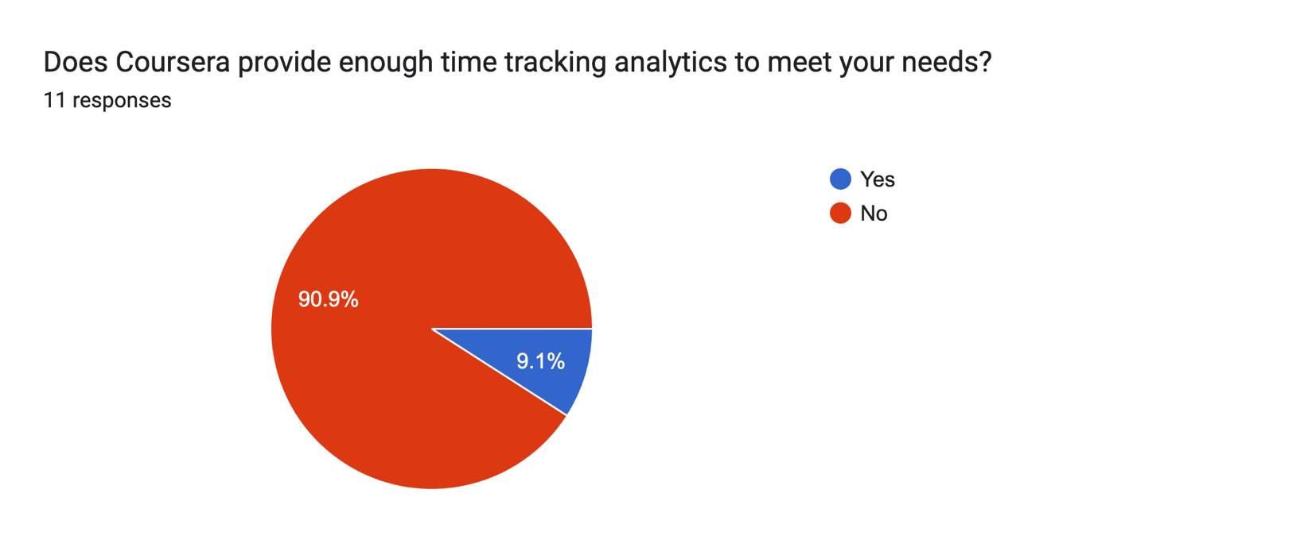

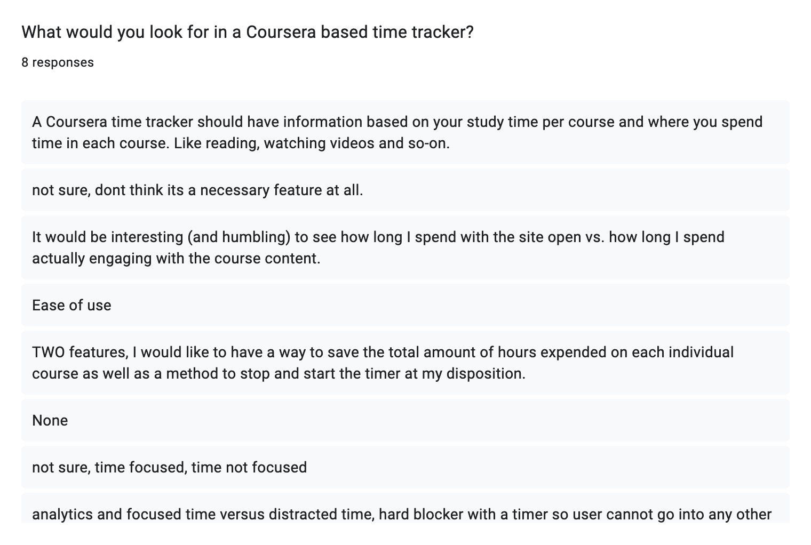

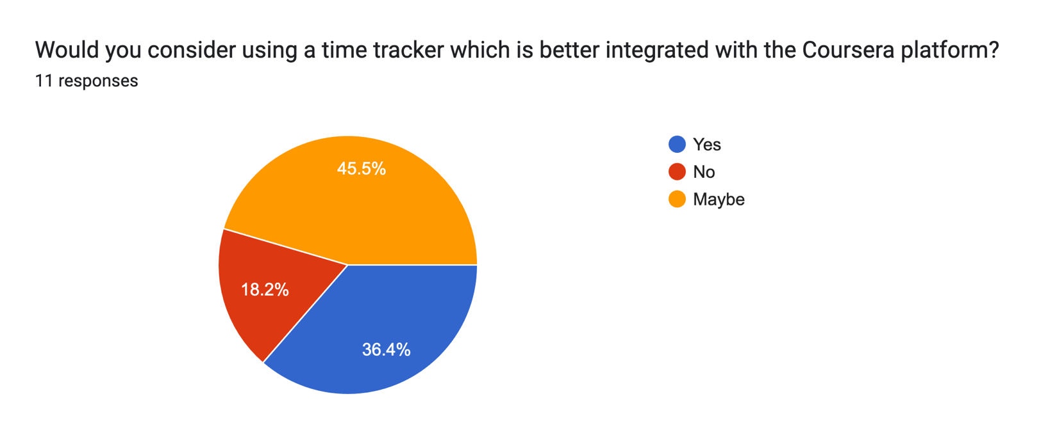

### 7.1.2 Low-Fidelity Prototype Questionnaire

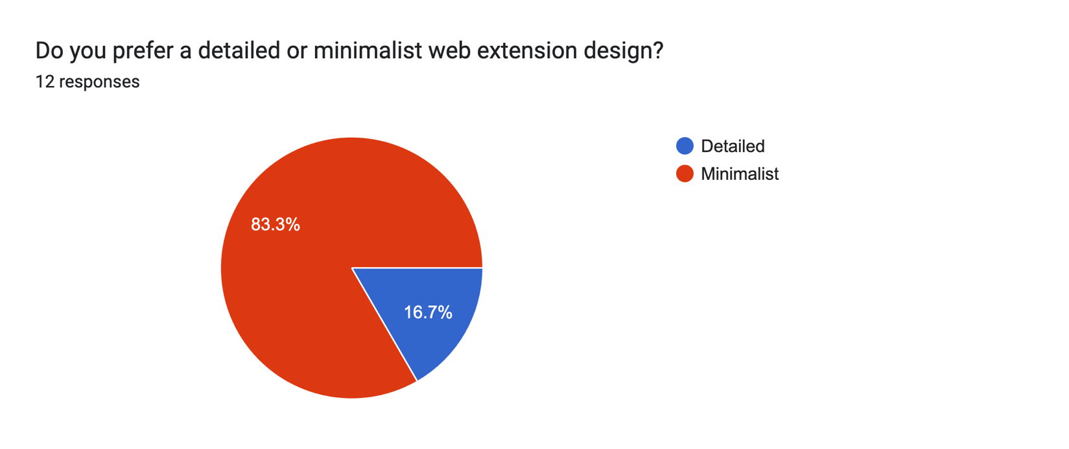

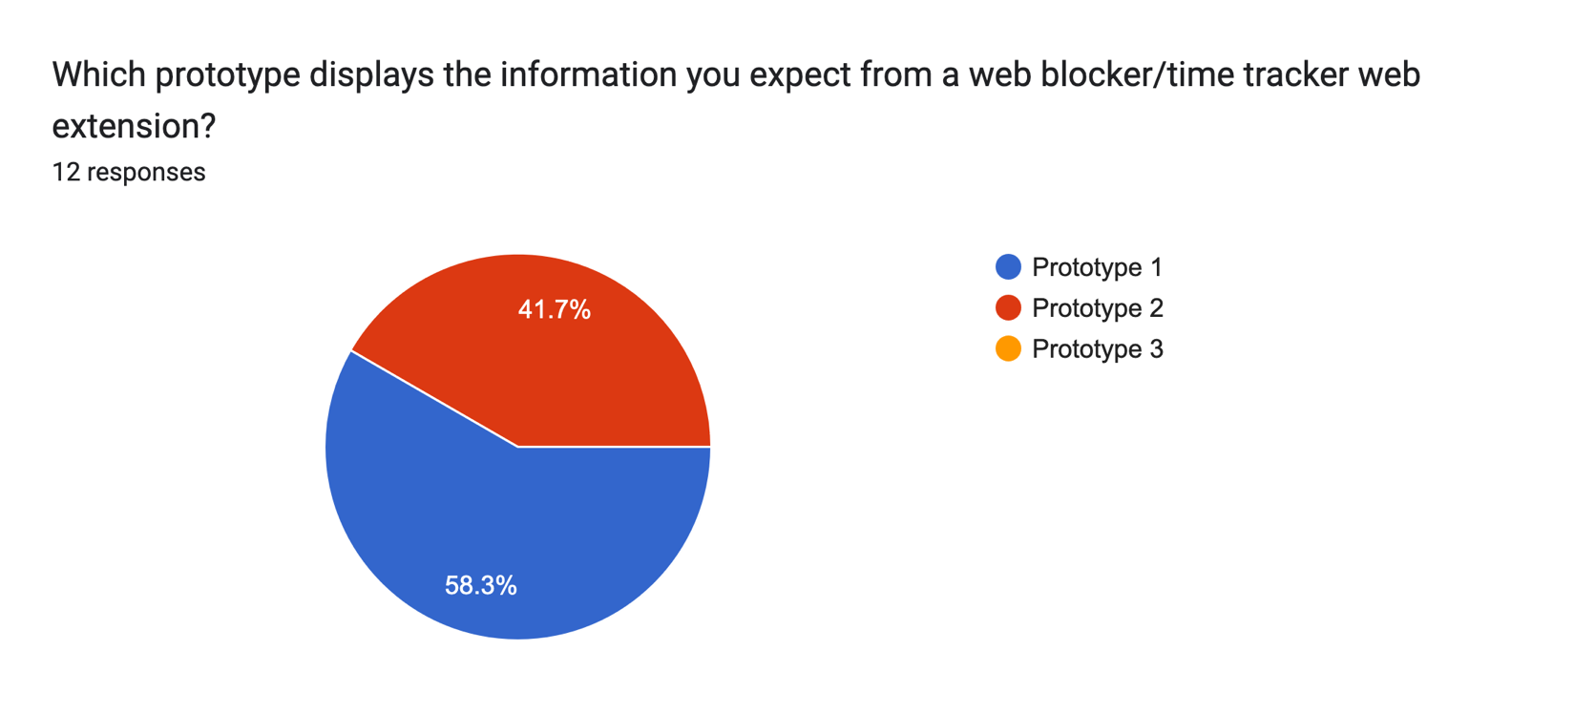

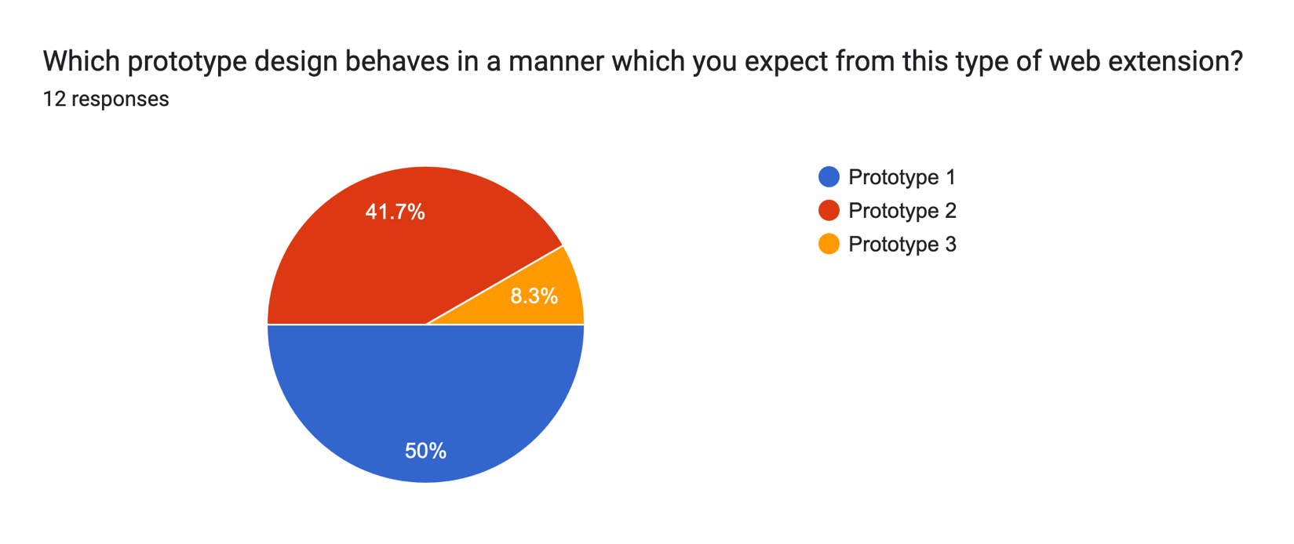

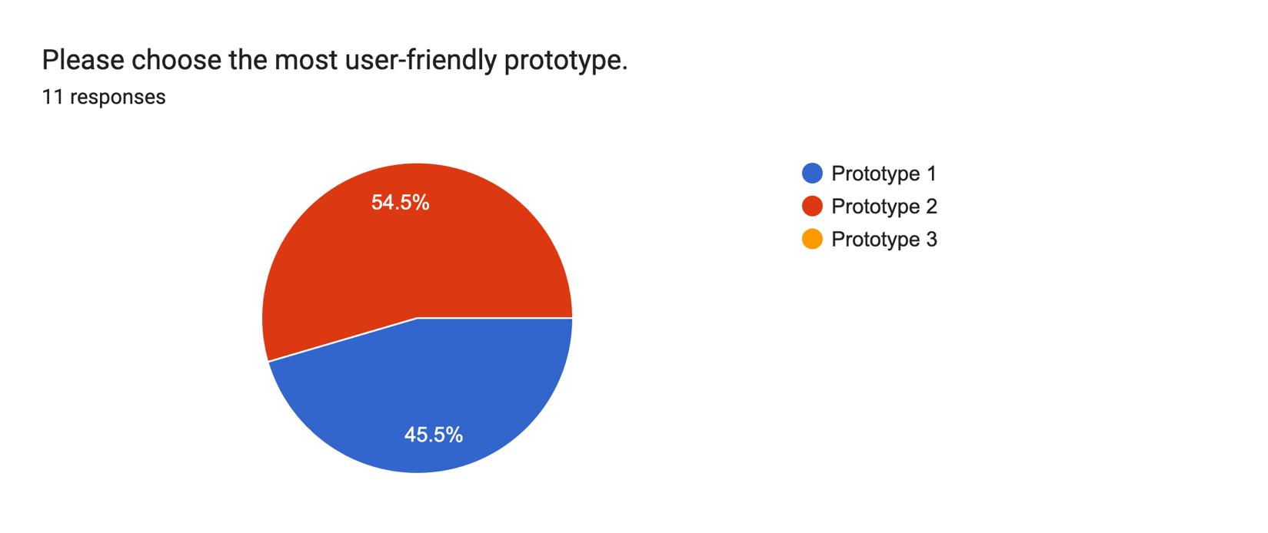

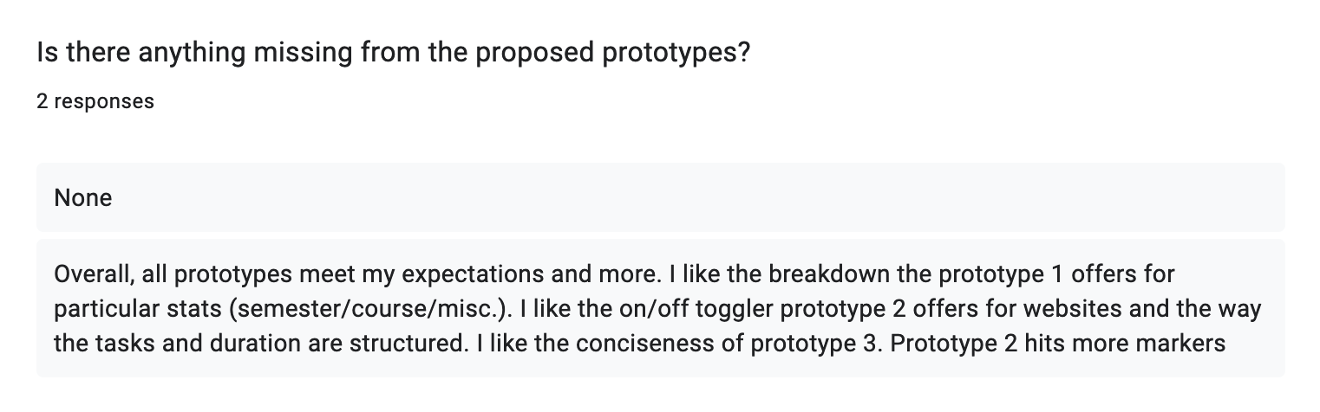

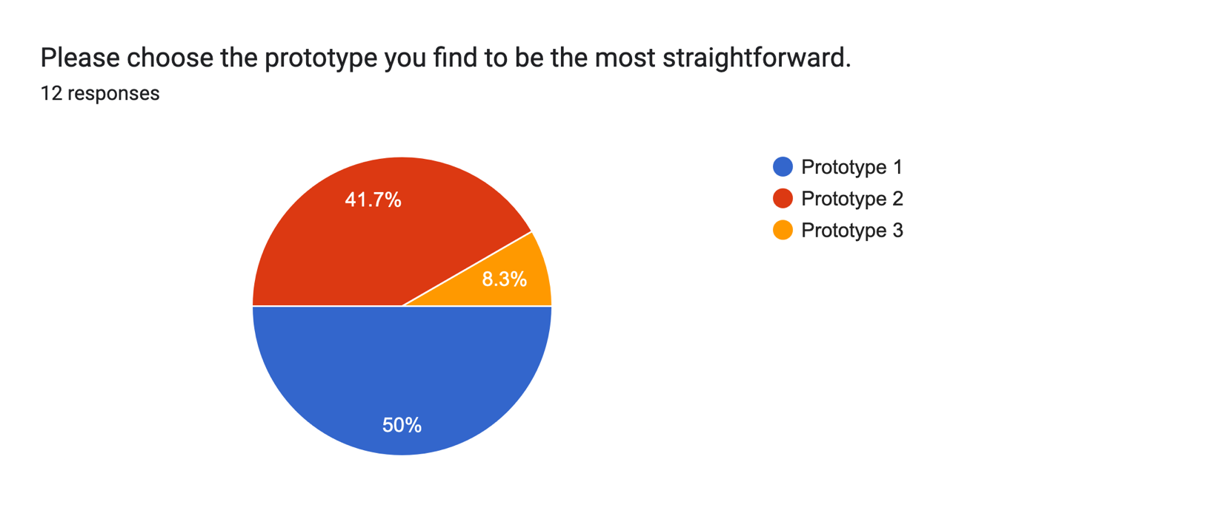

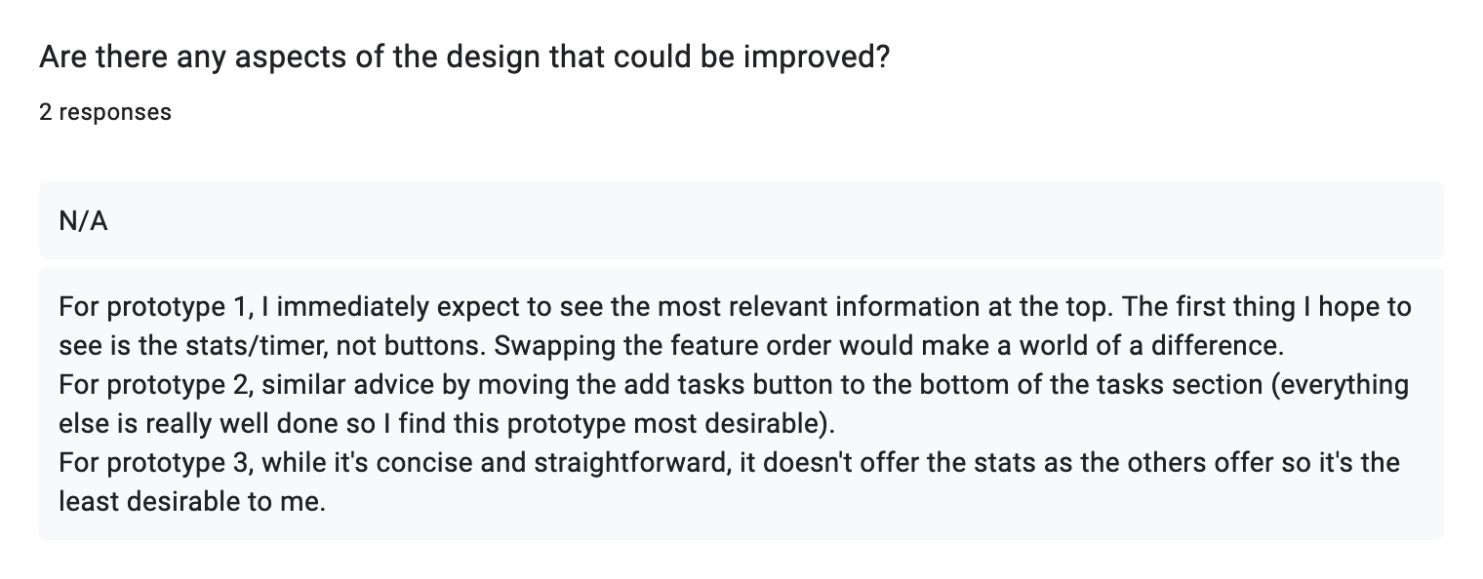

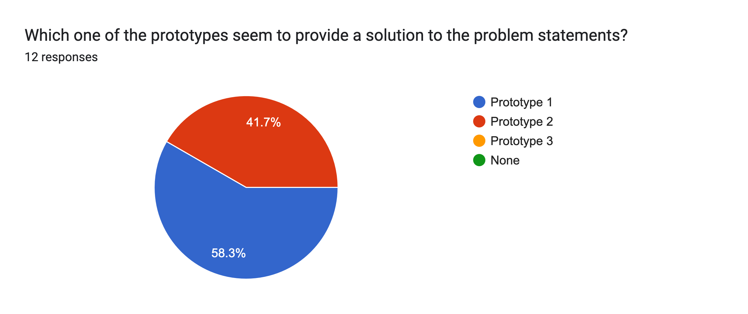

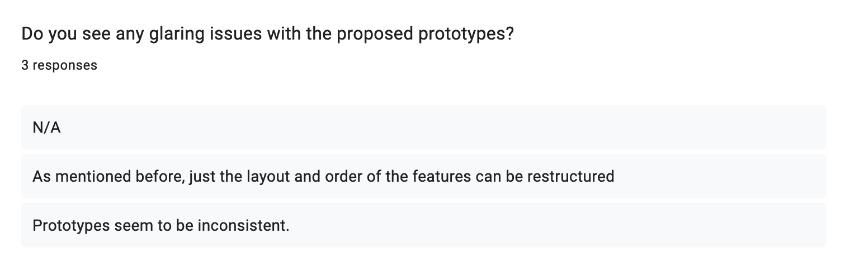

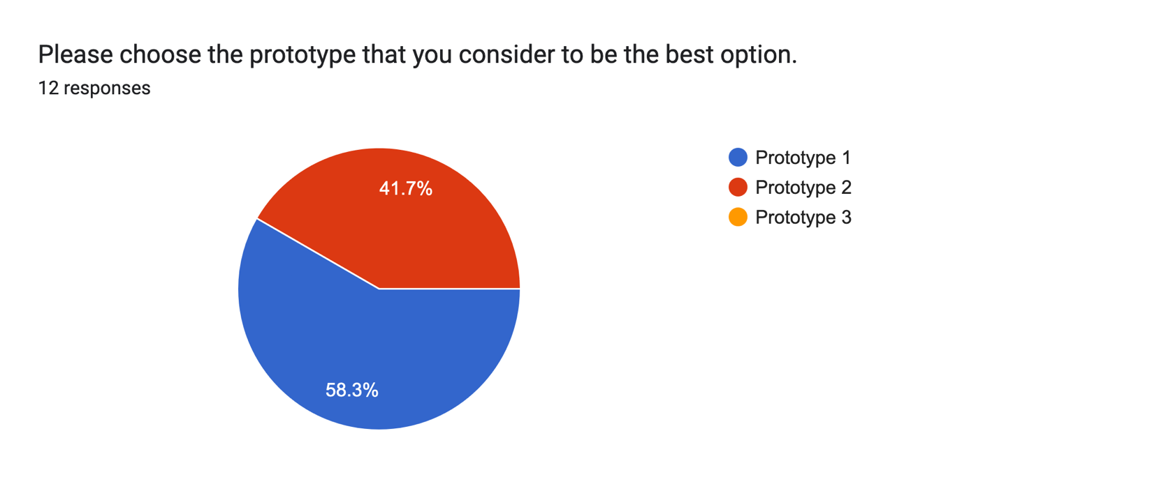

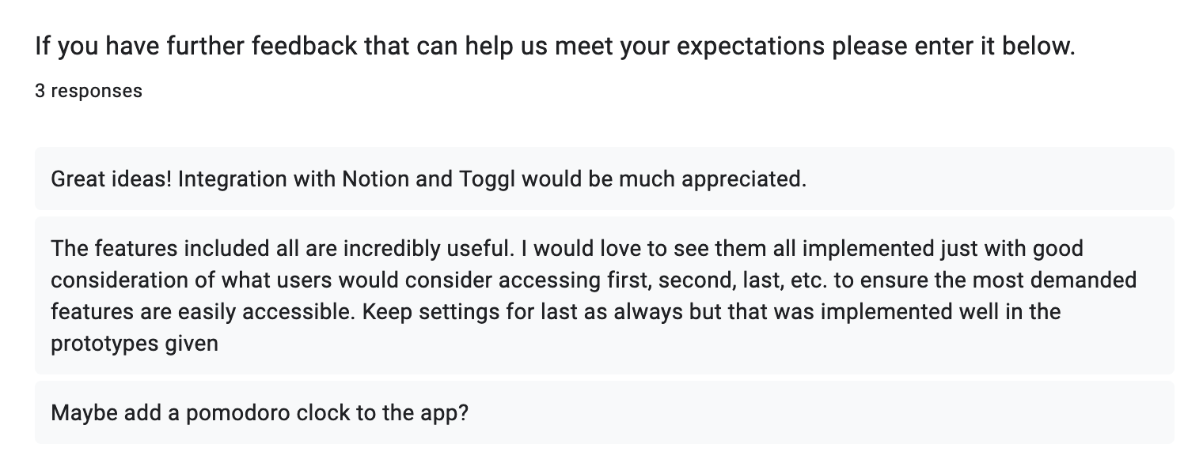

### 7.1.3 User Requirements Questionnaire

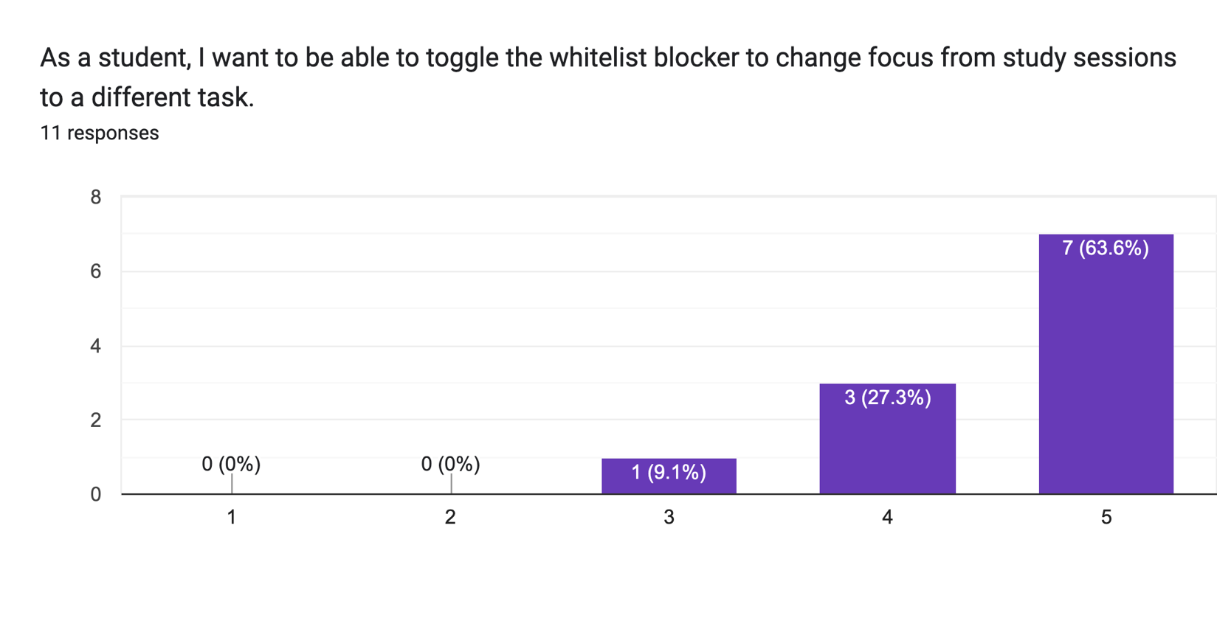

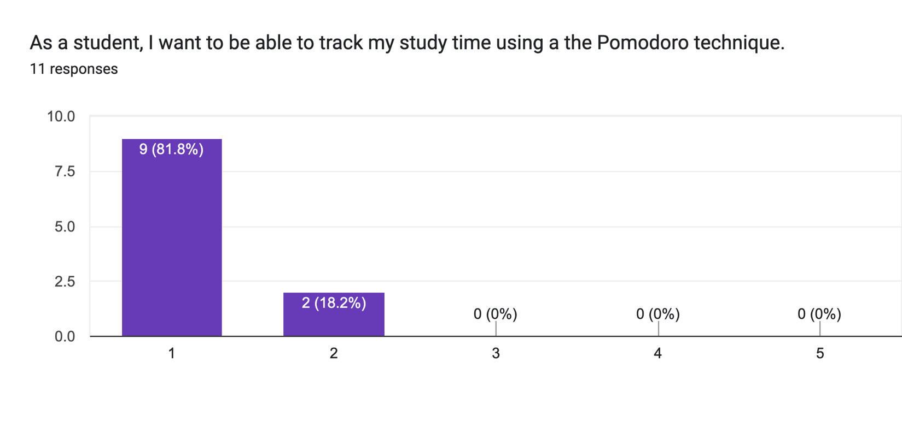

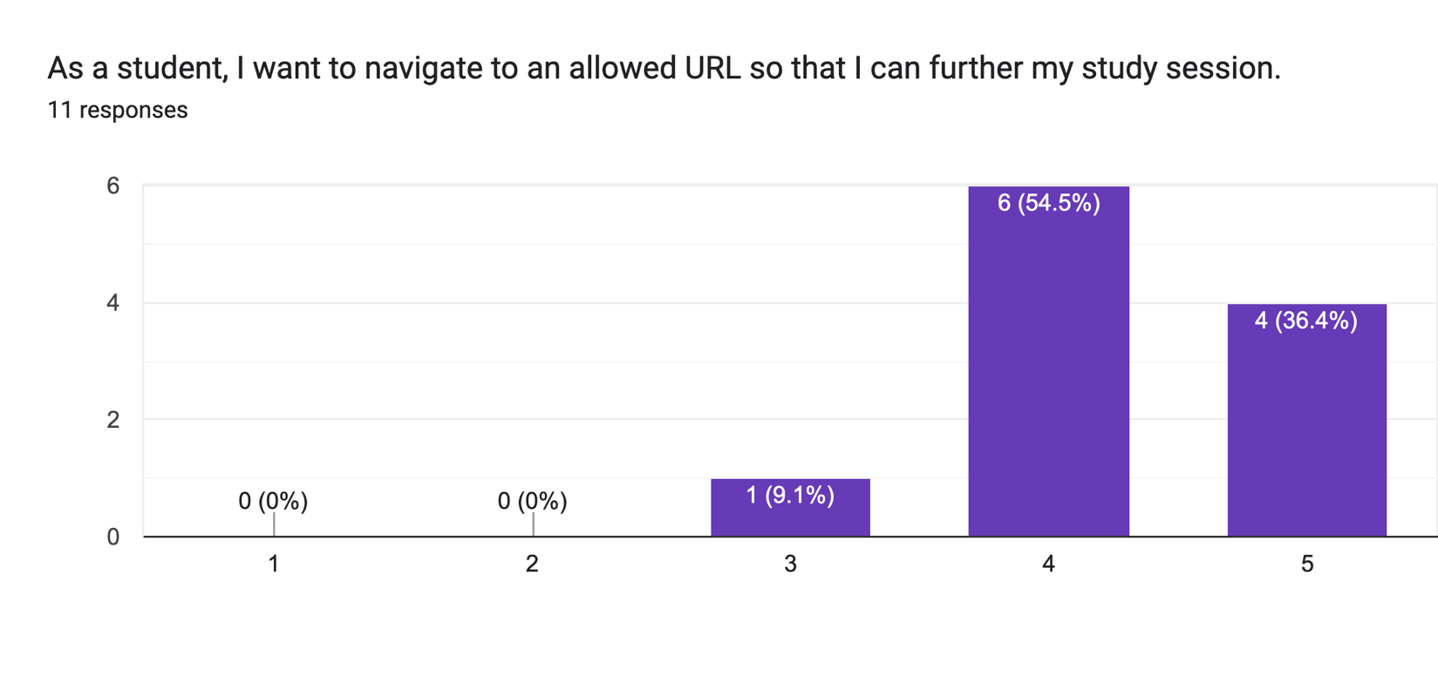

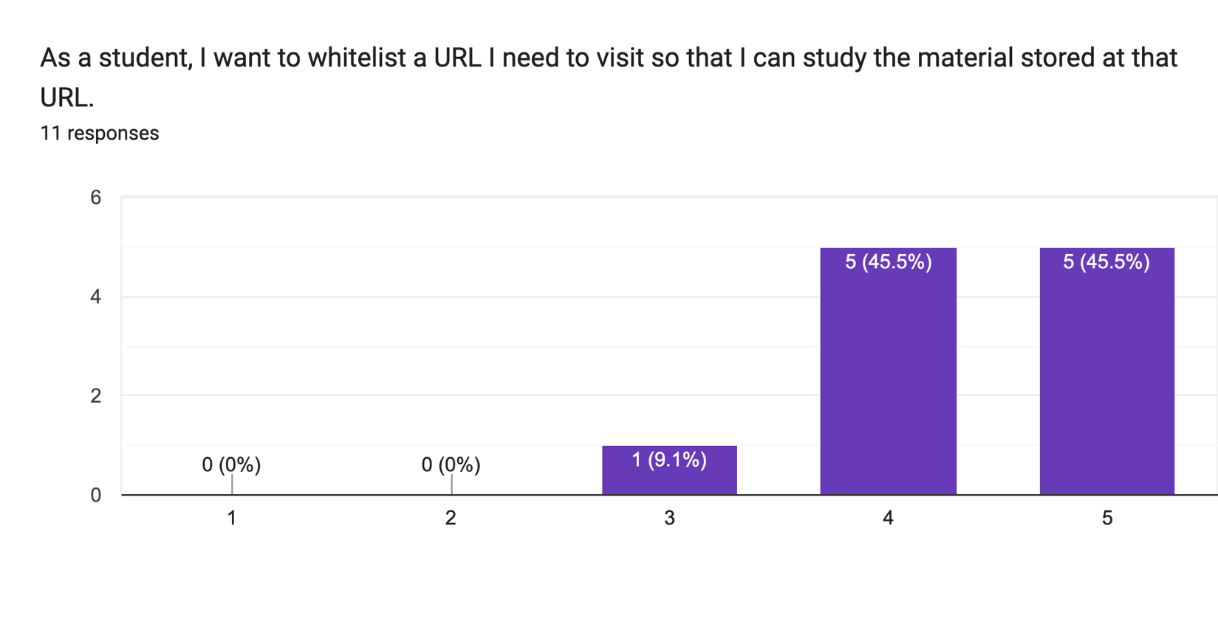

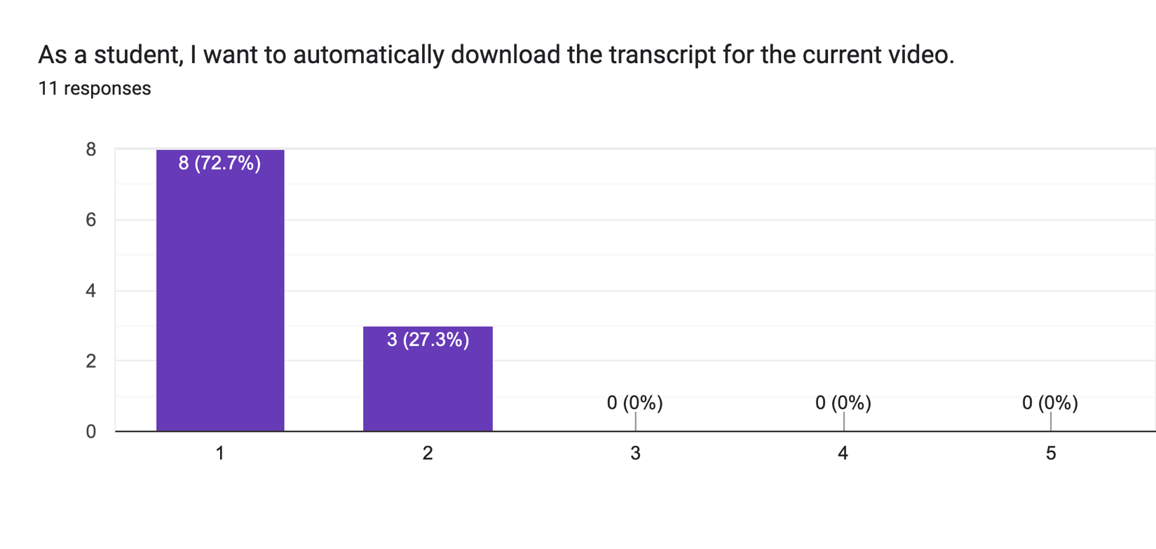

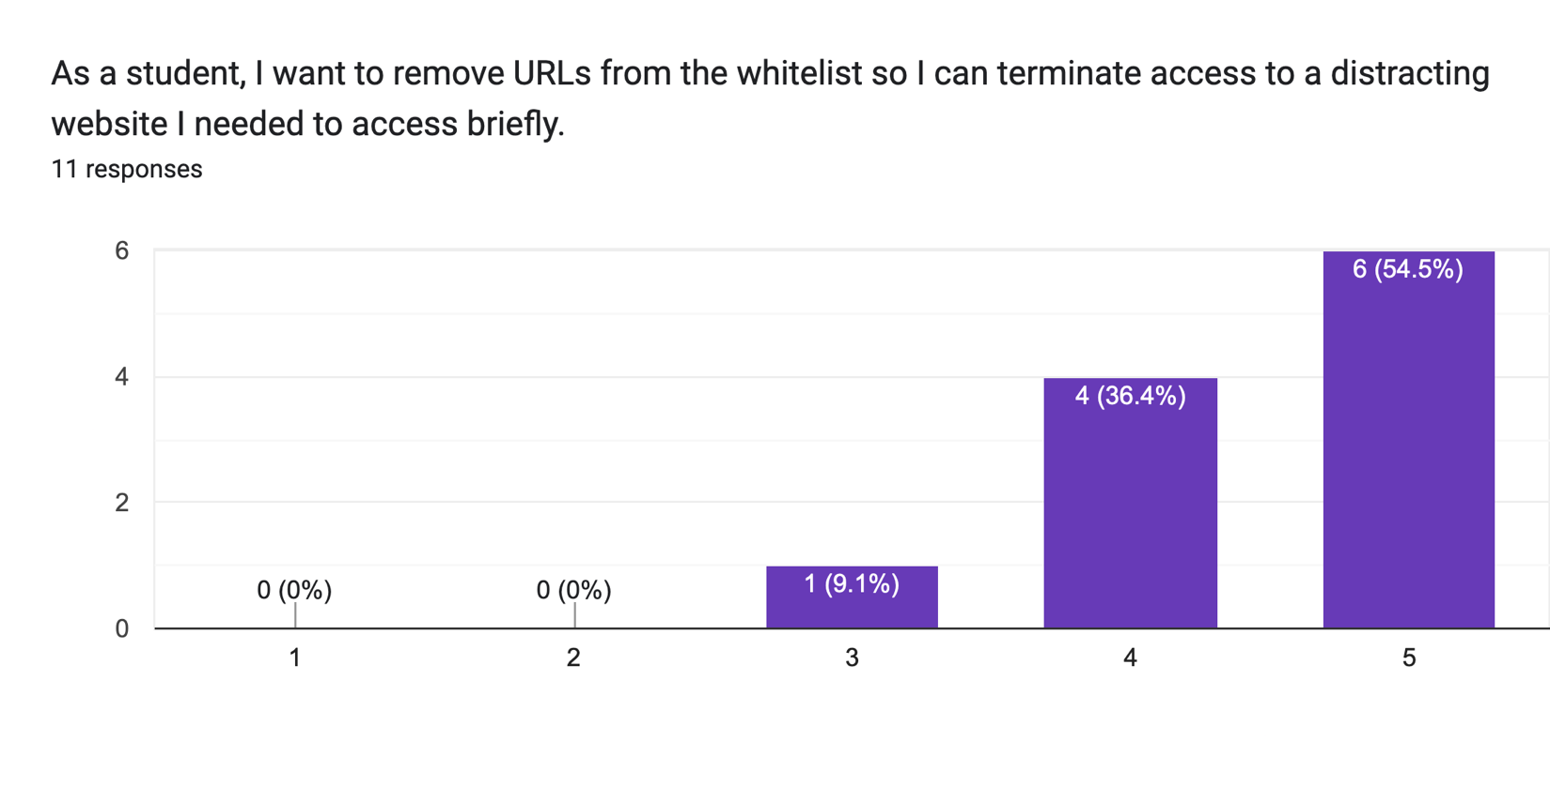

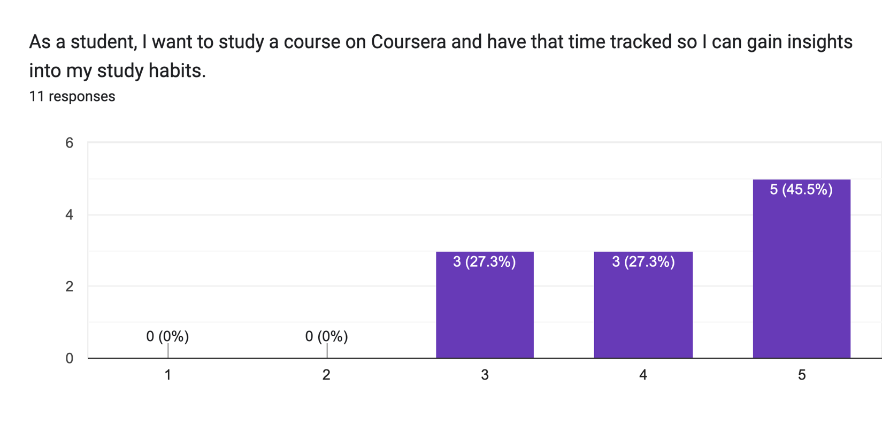

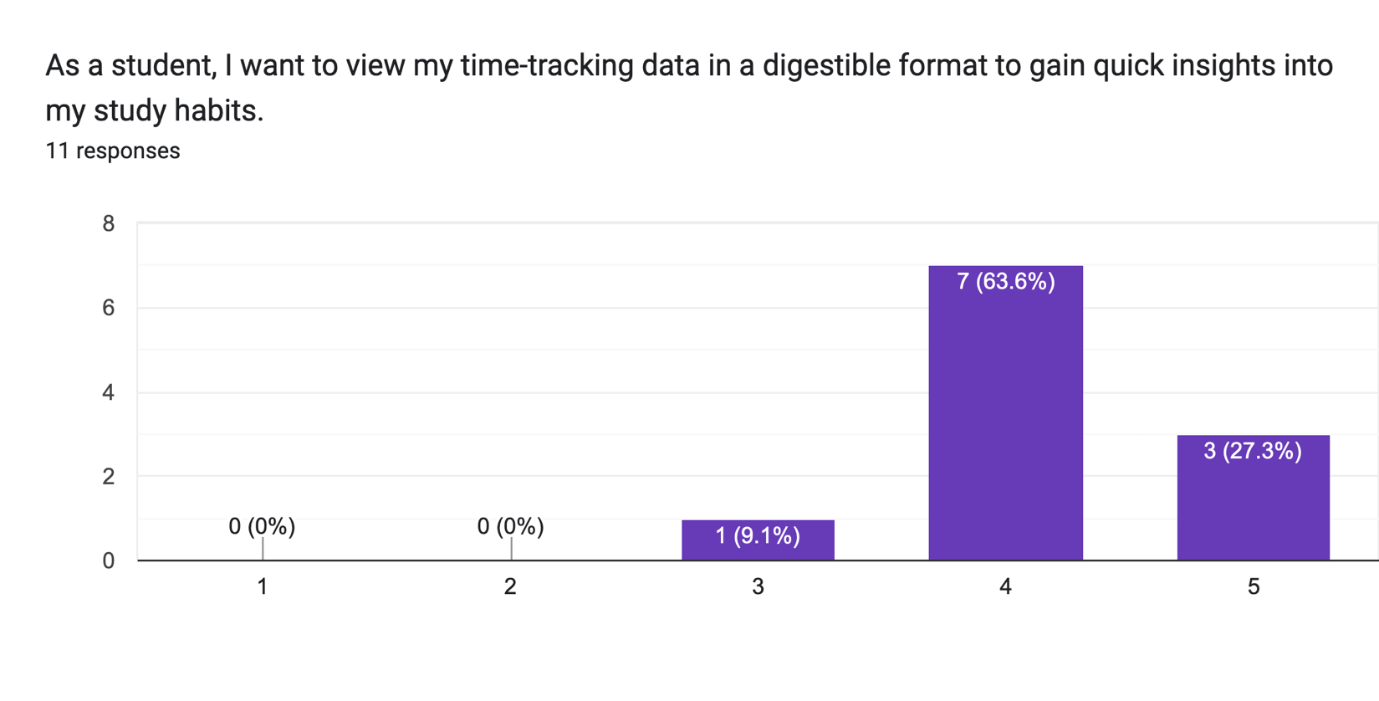

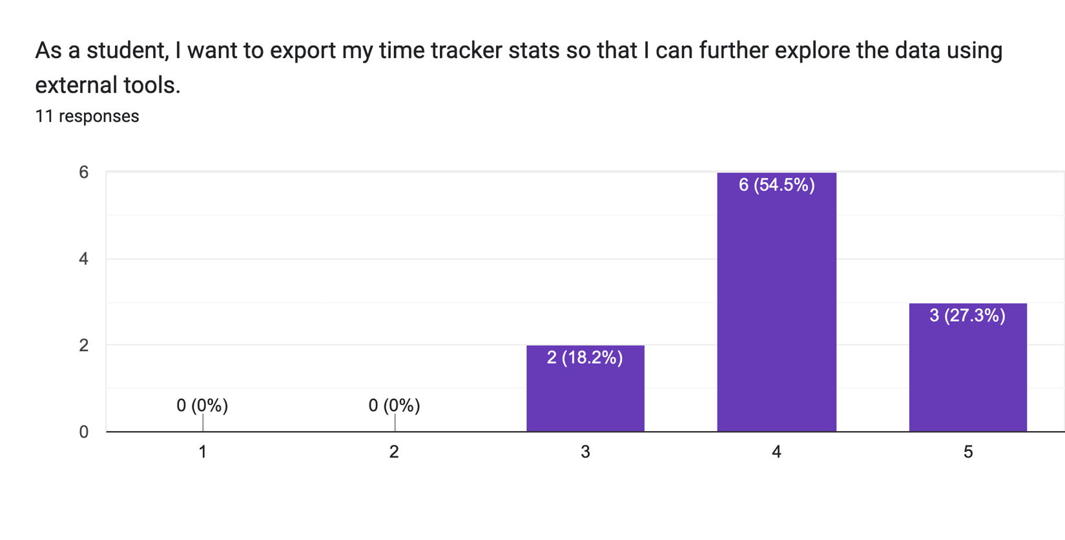

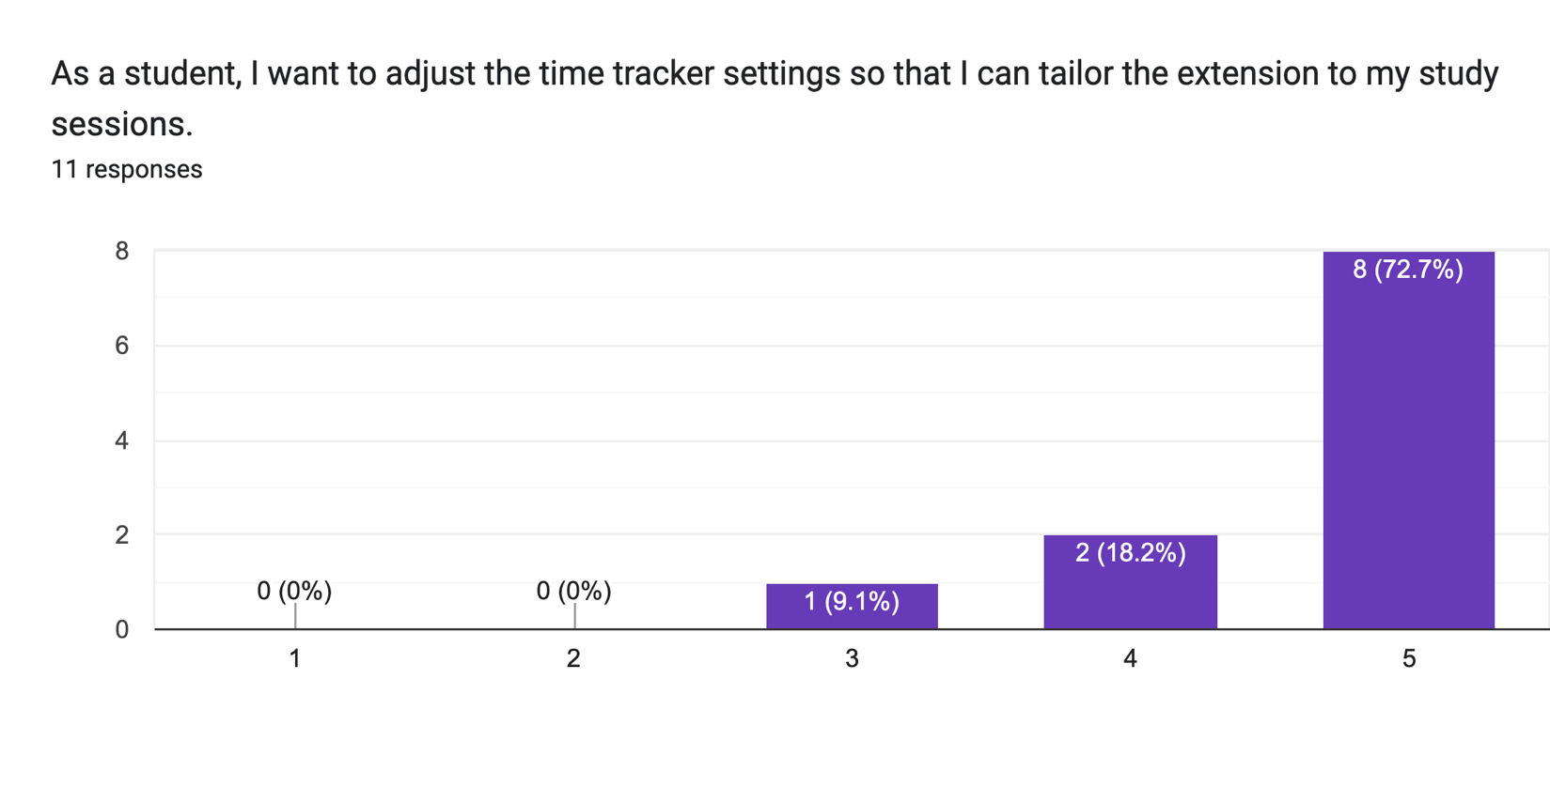

### 7.1.4 High-Fidelity Prototype Questionnaire

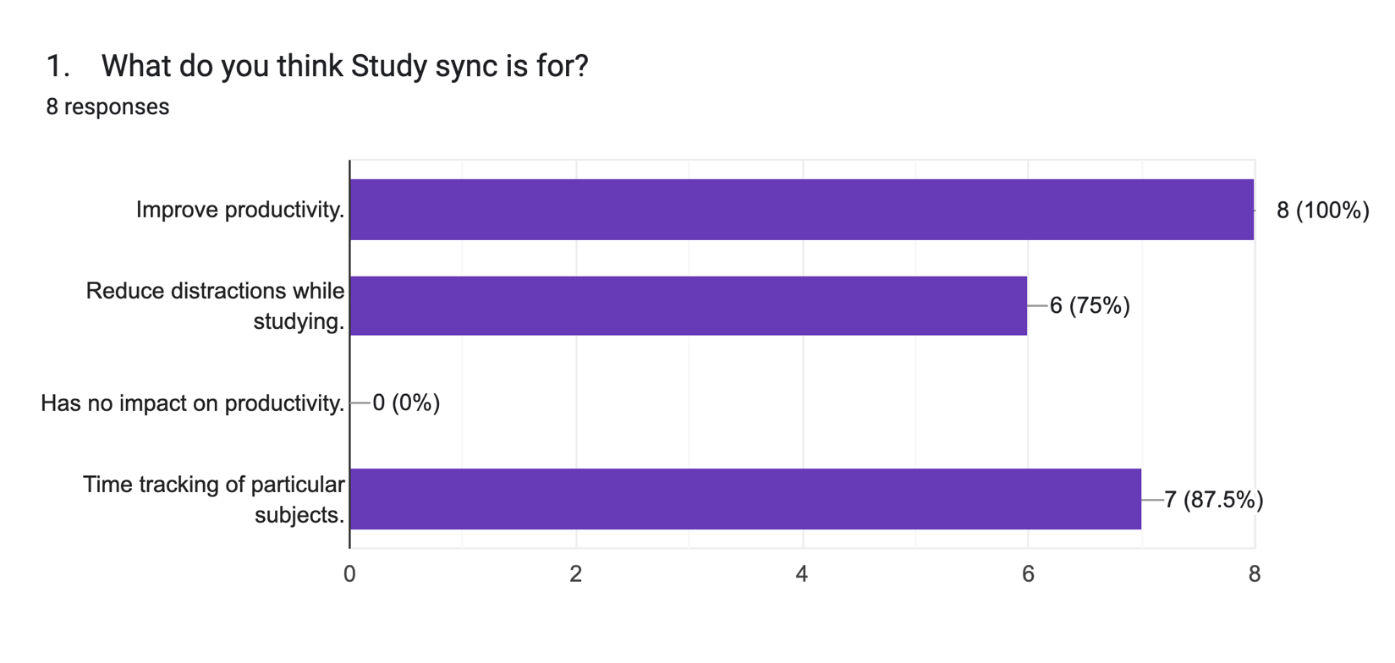

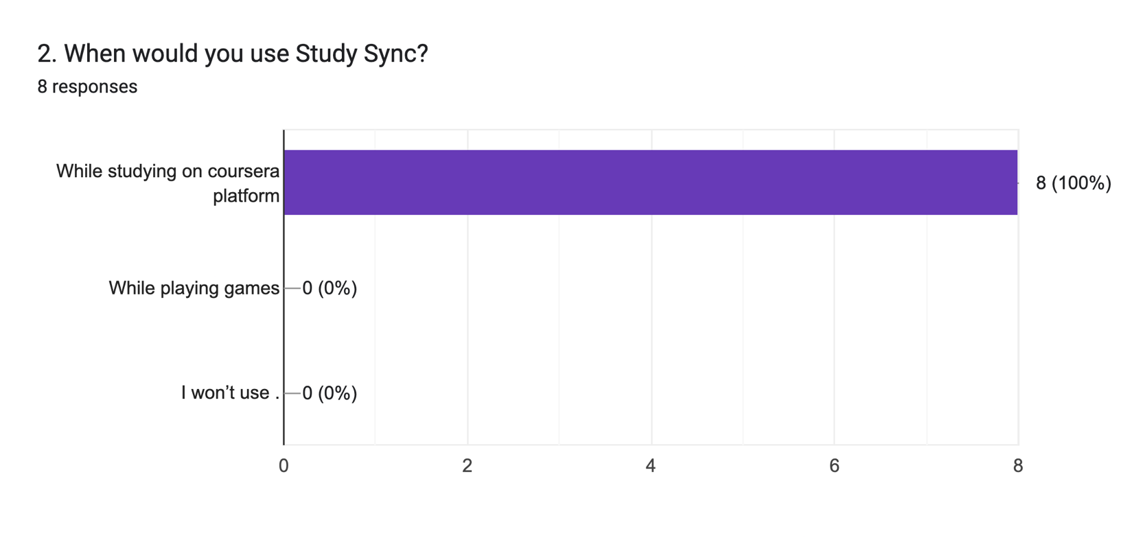

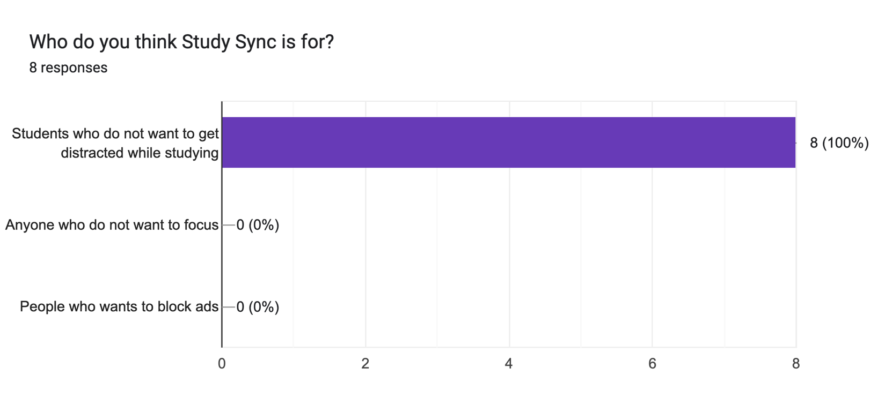

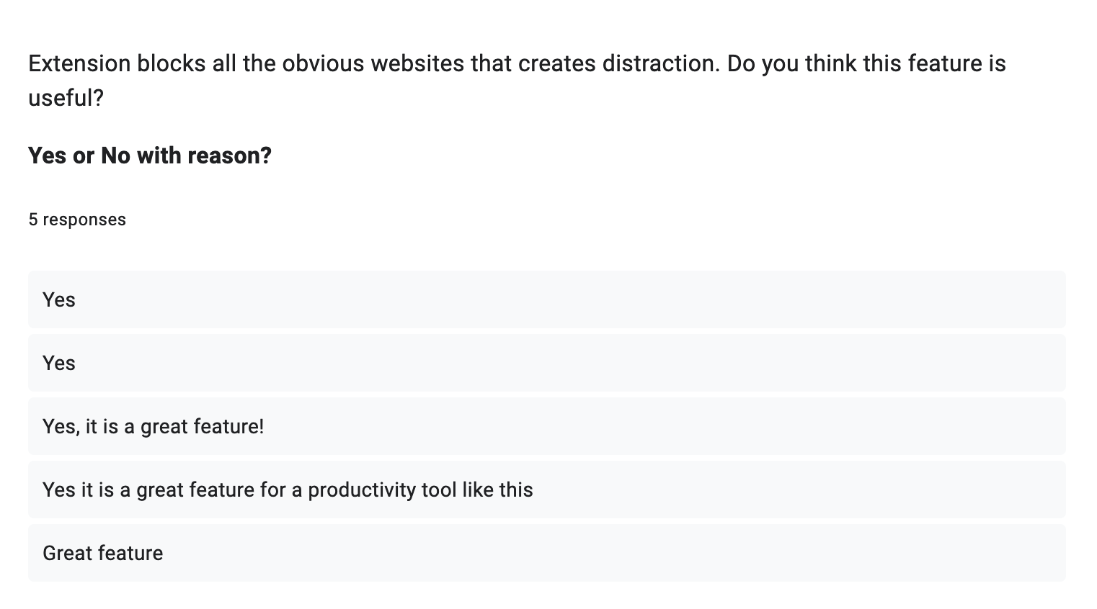

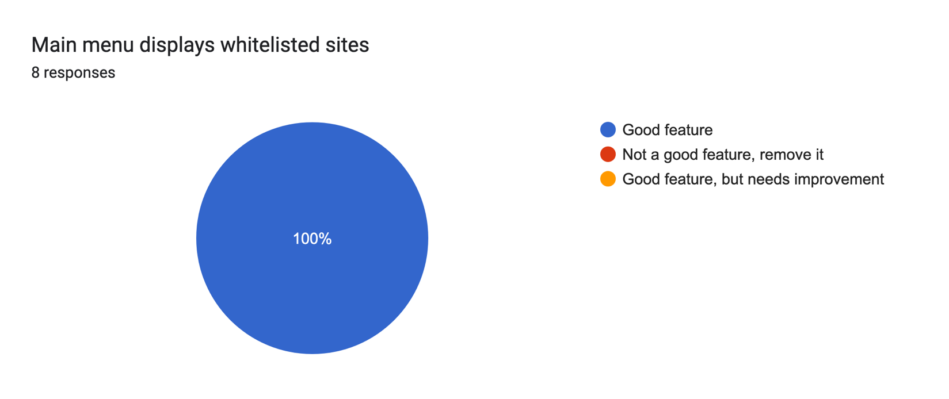



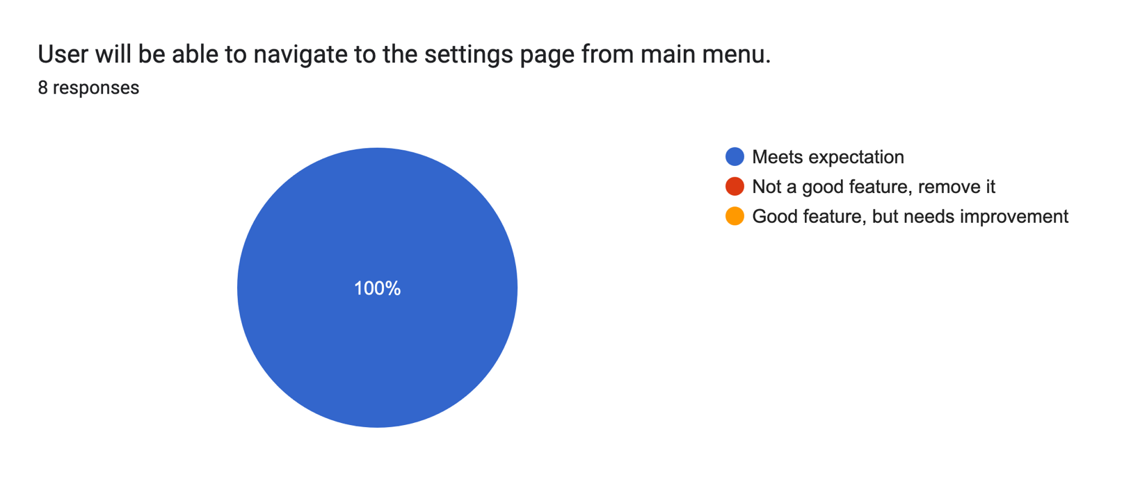

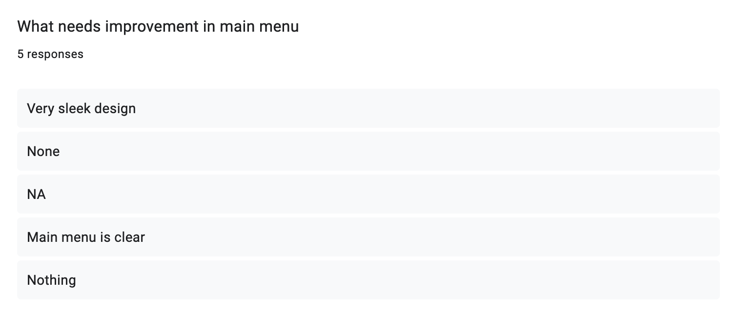

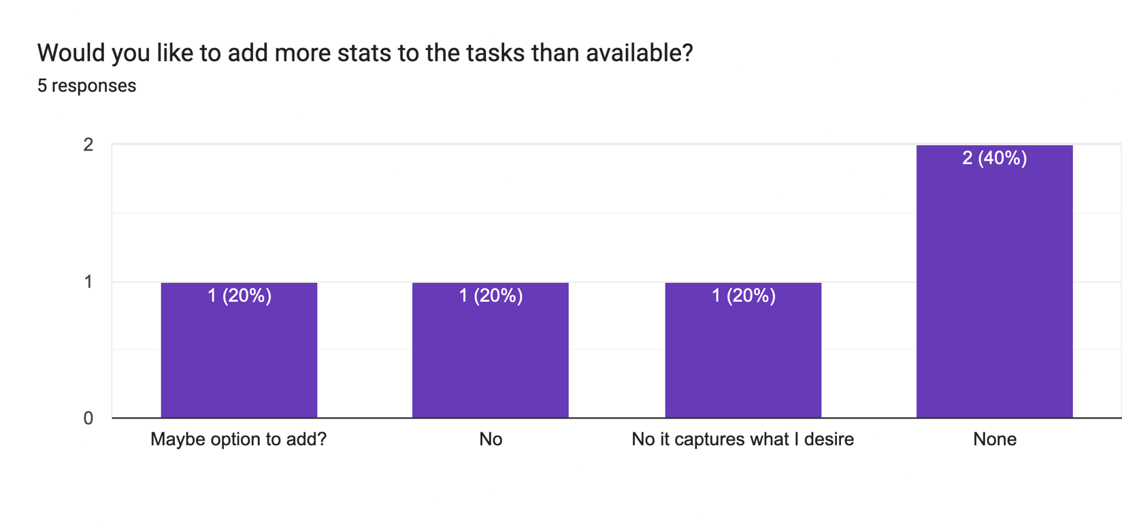

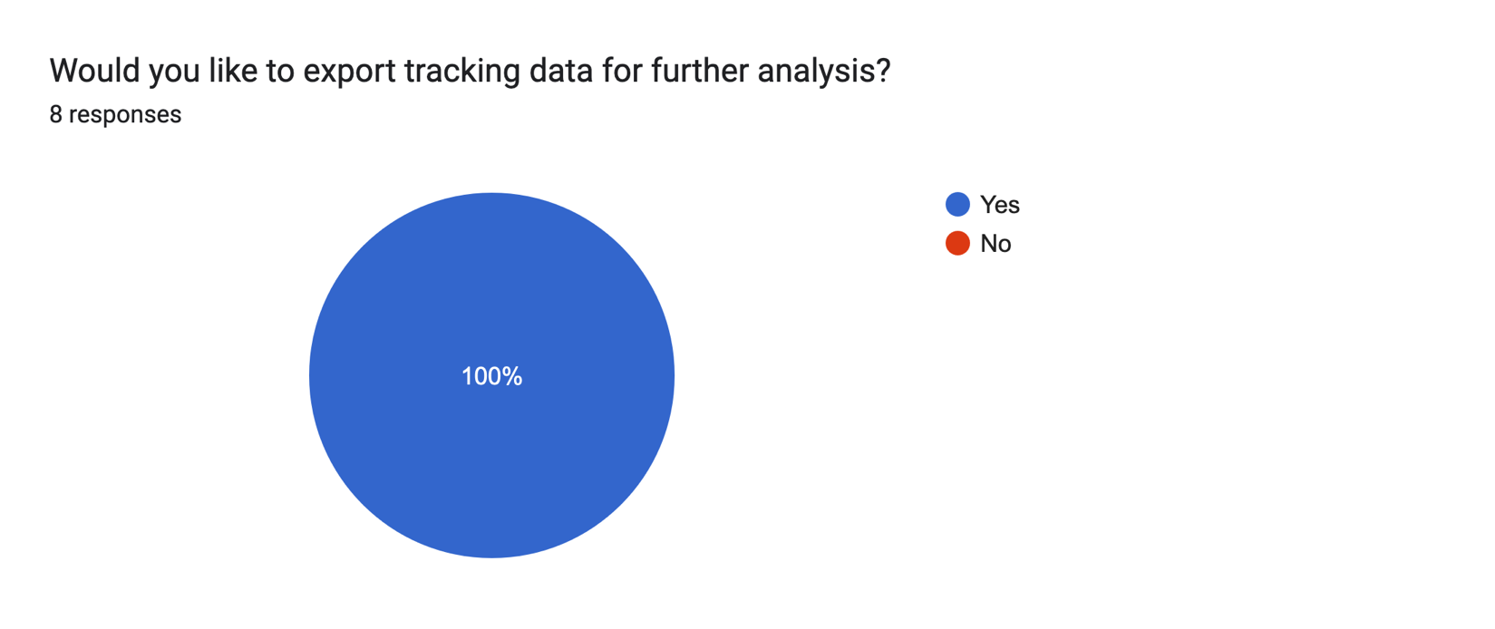

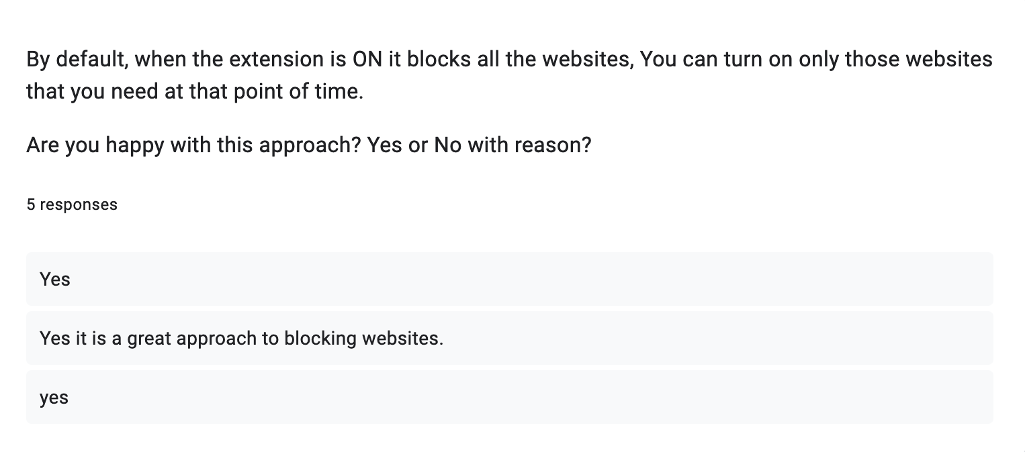

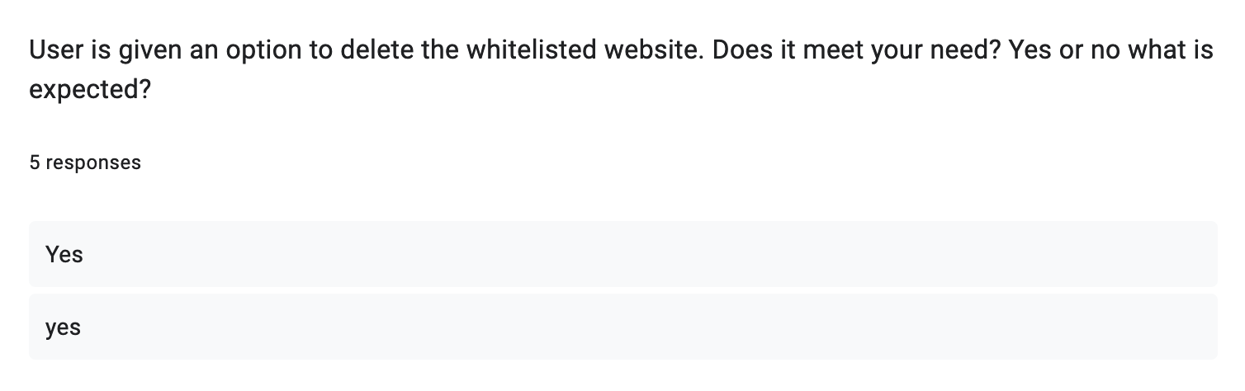

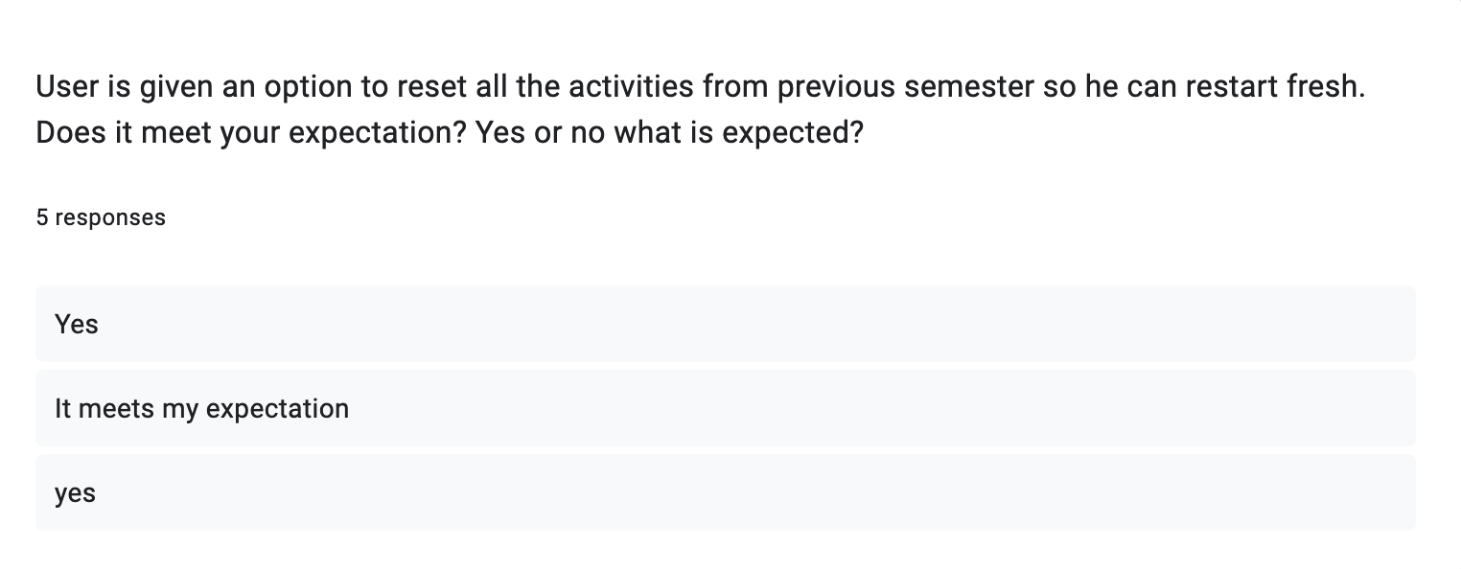

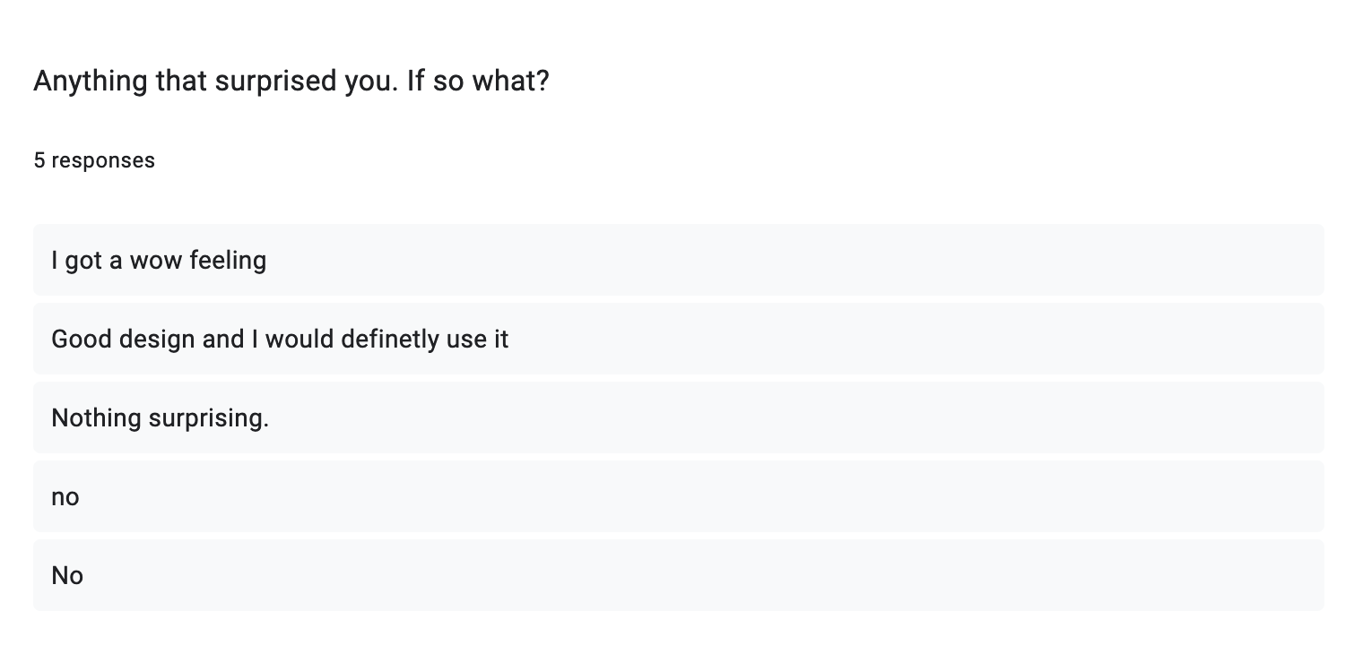

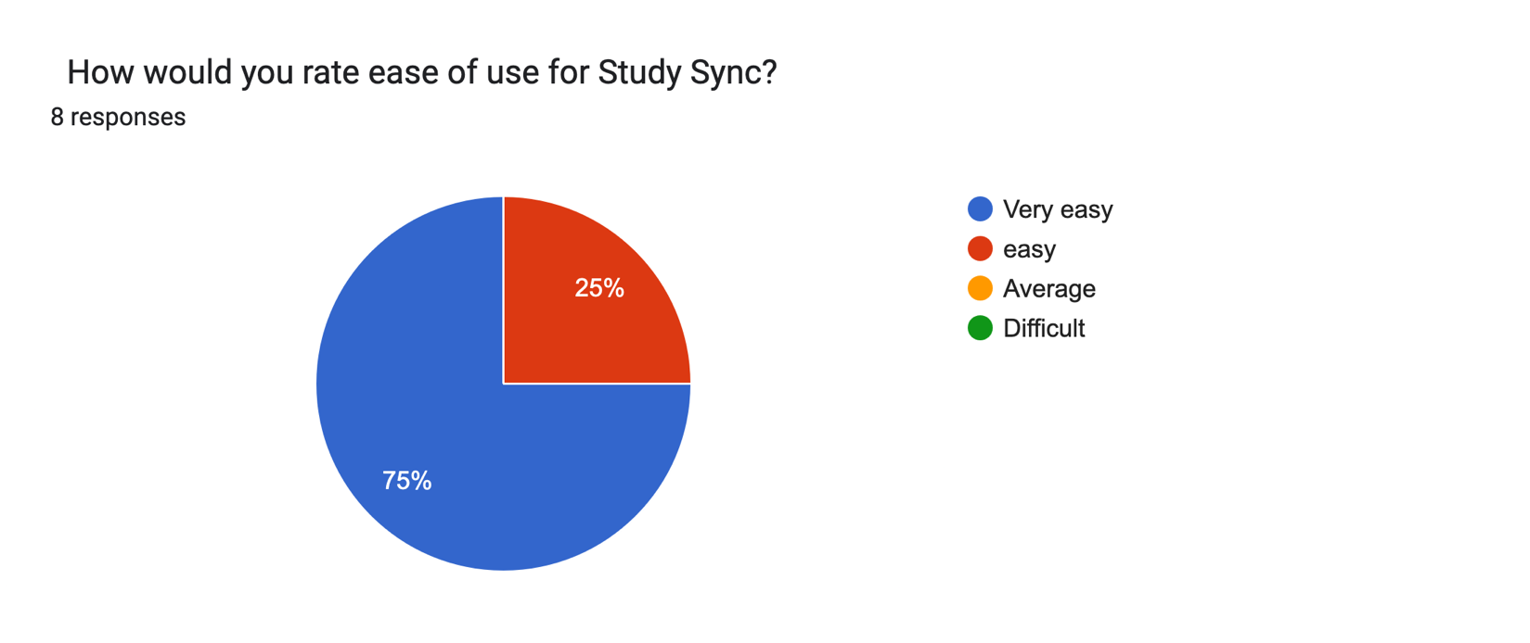

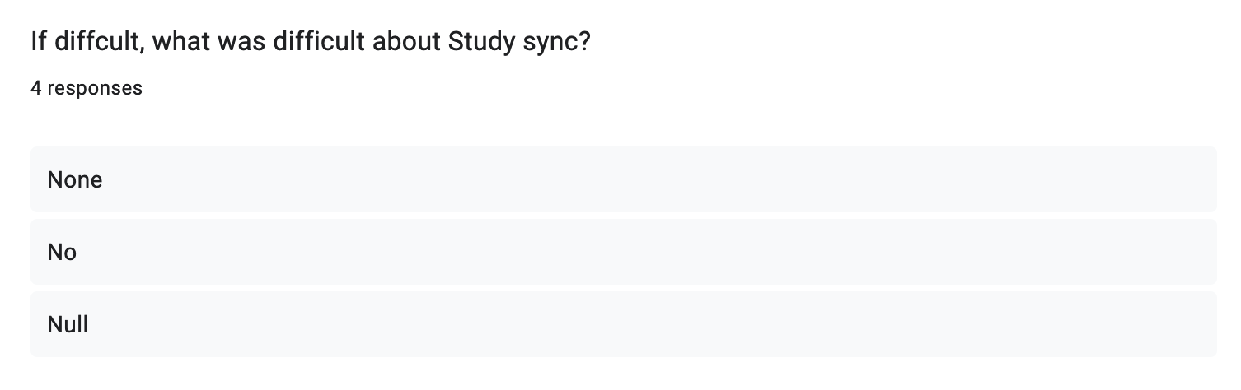

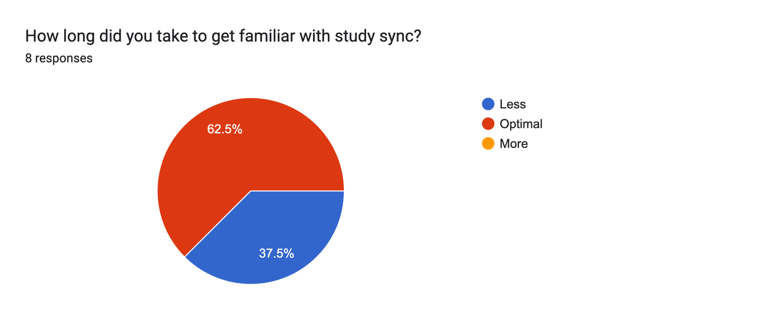

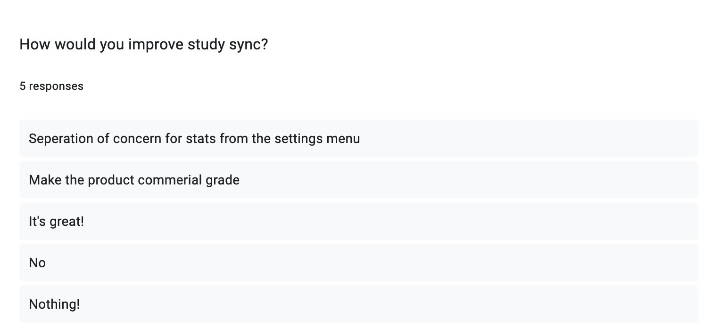

## 7.2 Storyboards

### 7.2.1 US-2 Storyboard

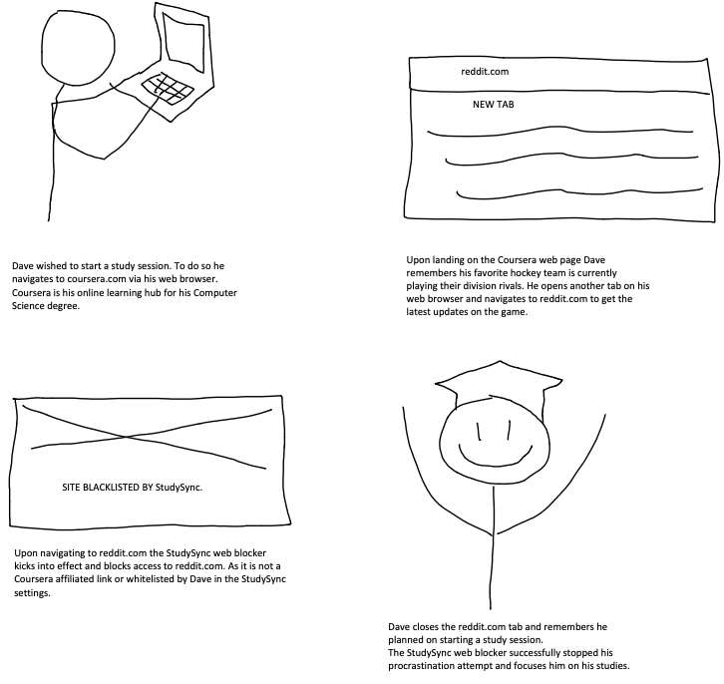

### 7.2.2 US-6 Storyboard

